MECHANICS III

Remember to photocopy 4 pages onto one sheet by going A3→A4 AND back to back on the photocopier

Student name: ________________________________

This booklet contains every higher and ordinary level question that has appeared on an exam paper on this topic from 2002–2023
Worked solutions to Ordinary Level Maths questions can be found at the end of the booklet.
Fully worked solutions to all higher level past papers can be found on the homepage of thephysicsteacher.ie

Screencasts of all topics plus a wide range of other resources via this link

You can find this document plus all other booklets on the homepage of thephysicsteacher.ie
Last updated: 04/08/2024
Noel Cunningham
Contents
1: VECTORS 3
The magic of vectors 4
Resolving a vector into two perpendicular components 4
The inclined plane 7
Experiment: To find the resultant of two vectors 9
Composition (addition) of two perpendicular vectors 10
SLOP 12
The science of learning quiz: Part 13 13
2: CIRCULAR MOTION 15
Student Notes 15
Radians 15
Angular velocity 15
Relationship between linear speed (v), angular velocity (ω) and radius 16
To derive v = rω 16
Centripetal force 17
Centripetal acceleration 17
Formulae for centripetal acceleration and centripetal force 17
Circular motion exam questions: worked examples 18
Satellite orbits 20
Derivation of formula for periodic time of a satellite 20
Geostationary Satellites 22
Background reading 23
SLOP 28
The science of learning quiz: Part 14 29
3: SIMPLE HARMONIC MOTION AND HOOKE’S LAW 31
Student Notes 31
Simple harmonic motion (S.H.M.) 31
Displacement, velocity, acceleration and force for an object undergoing SHM 32
Relationship between T and ω for an object undergoing SHM 33
Hooke’s law 35
To show that any object that obeys Hooke’s Law will also execute SHM 35
Simple harmonic motion with Hooke’s law: all Higher level 36
Periodic time of a simple pendulum 40
INVESTIGATION OF THE RELATIONSHIP BETWEEN T AND l FOR A PENDULUM 41
SLOP 45
MECHANICS III EXAM QUESTIONS 2002 – 2023 47
Force and vectors: Higher level 47
Circular motion: All Higher level 50
Circular motion and gravity: all Higher level 52
Simple harmonic motion: all Higher level 56
Simple harmonic motion with Hooke’s law: all Higher level 57

1: VECTORS

This idea is so crazy that I usually leave it until sixth year – it causes more difficulty than any other concept in Mechanics (with the possible exception of circular motion, also left to sixth year).

“The vector has never been of the slightest use to any creature." Lord Kelvin

Student Notes

Examples of scalar quantities | Examples of vector quantities
Mass | Weight
Length | Force
Distance | Displacement
Speed | Velocity
Power | Acceleration
Energy (or work) | Thrust
Temperature | Momentum
A scalar quantity is one which has magnitude only.
A vector quantity is one which has both magnitude and direction.
The fact that a quantity like force has a direction associated with it allows us to assign it a positive or negative sign and this is very useful when adding vectors. So if student A pushes a car with a force of 100 newtons to the right and student B pushes the car with a force of 60 N in the opposite direction, we can calculate the net force as follows.
Force due to student A = 100 N
Force due to student B = - 60 N
And now we just add the two forces while keeping track of their respective signs.
F_{net} = Force A + Force B = 100 + (- 60) = 40 N towards the right.
In a nutshell, if the quantity in question is a vector then you have to keep track of the direction; if you have two of the same quantity acting in opposite directions then you have to assign one as negative. We can’t do this for all physical quantities however (it wouldn’t make sense to assign a direction to mass or area for example) so as a result all physical quantities can be categorised as being either vector or scalar in nature.

Another way to think about vectors is to appreciate that they obey something called the laws of vector algebra (see example above; it just means that we have to keep track of the negative numbers). And as if that wasn’t enough, vectors can be represented on a diagram by an arrow, where the vector is in the same direction as the quantity it is representing and the relative size of the vector reflects the magnitude (we have already seen this in relation to maths questions involving acceleration due to gravity and some conservation of momentum problems.

2018 HL Question 5  Draw a labelled diagram to show the forces acting on a skydiver falling with a constant velocity. | 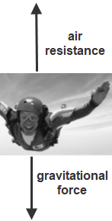  Note that for questions such as this one the marking scheme requires that you make the arrows of equal length to reflect that they are equal in size.

The magic of vectors
But we still haven’t been introduced to vector’s most magical attribute – that honour goes to the following madcap idea: a vector quantity can be split (‘resolved’) into perpendicular components and each of these components can then be treated separately. The most common example of this is when we resolve velocity of a projectile into different components.

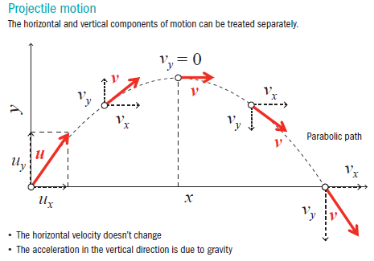

Resolving a vector into two perpendicular components
First we need to remember that for a right-angled triangle:

Cos θ = $\frac{Adjacent }{Hypothenuse }$, therefore Adjacent = Hypothenuse × Cos θ {Adjacent = H Cos θ}
Sin θ = $\frac{Opposite}{Hypothenuse }$, therefore Opposite = Hypothenuse × Sin θ {Opposite = H Sin θ}

Examples

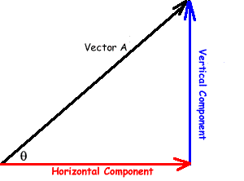
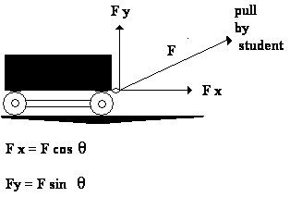
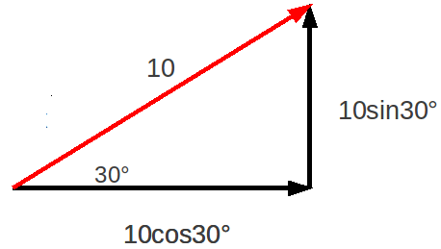

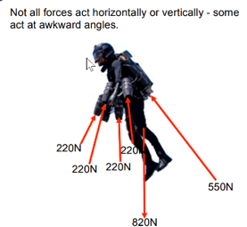 | 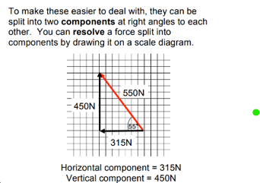

Worked example
Consider a velocity vector representing a velocity of 50 m s⁻¹ travelling at an angle of 60⁰ to the horizontal
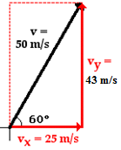
Find the horizontal and vertical components.

Solution
See diagram
The opposite is equal to H Sinθ, which in this case = 50 Cos 60⁰ = 43 m s⁻¹.
The adjacent is equal to H Cosθ, which in this case = 50 Sin 60⁰ = 25 m s⁻¹.

Fill in the following table (leave your angle in surd form where possible)

Magnitude | Angle | Horizontal component | Vertical component
20 | 45⁰
10 | 30⁰
8 | 75⁰
20 | 60⁰
12 | 15⁰

2023 Deferred Question 6 (Higher level)  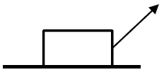  A child drags a box across a horizontal floor with a force of 44 N applied at 47° to the horizontal. The friction between the box and the floor is 20.5 N.  Calculate the net horizontal force on the box. | We mentioned earlier that each component can be treated separately. Here we are only interested in the horizontal direction.  F_{Horizontal} = 44 cos60 = 22 N  F_{Net} = 22 – 20.5 = 1.5 N to the right
2021 Question 5 (Higher level)  A ball is kicked with an initial velocity of 20 m s⁻¹  at an angle of 50° to the horizontal.  Calculate the horizontal distance it travels in 1.2 seconds. | First we need to work out how fast the ball is travelling in the horizontal direction.  u = v_{Horizontal} = 20Cos50° = 12.86 m s^{–1}  Now use s = ut  s = (12.86)(1.2) = 15.43 m
2015 Question 5 (Higher level)  A hurler strikes a sliothar (ball) with an initial velocity of 41 m s⁻¹ at an angle of 30° to the horizontal.  How far does the ball travel horizontally in three seconds? | First we need to find out the initial velocity of the sliothar in the horizontal direction.  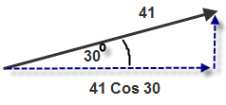  u = v_{Horizontal} = 41Cos30⁰ = 35.51 m s^{–1}  Note also the velocity in the horizontal direction doesn’t change because there is no force acting in that direction.  Now use s = ut  s = (35.51)(3) = 106.52 m
2018 Question 6 (b) [Higher Level]  A long-jump athlete has a velocity of 10.9 m s^{–1} at an angle of 43° to the horizontal when he begins his jump.  Calculate his velocity in the horizontal direction. | 2018 Question 6 (b) [Higher Level]  A long-jump athlete has a velocity of 10.9 m s^{–1} at an angle of 43° to the horizontal when he begins his jump.  Calculate his velocity in the horizontal direction.
He lands 1.03 seconds after he takes off.  Calculate the length of the jump. | He lands 1.03 seconds after he takes off.  Calculate the length of the jump.
2014 Question 6 [Higher Level]  A golfball ball leaves the club head at a velocity of 63.6 m s^{–1} and at angle of 15° to the horizontal.  Calculate the maximum height reached by the ball.  Ignore the effect of air resistance. | First we need to calculate the initial velocity of the ball in the vertical direction:  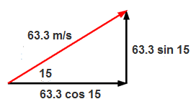  u_{y} = u sinϴ = 63.6 sin 15⁰ = 16.46 m s^{–1}  Now we can use v² = u² +2as  0 = (16.46)² +2(-9.8)s  height = s = 13.82 m  OR you could have used: ½mv² = mgh


2020 Question 6 [Higher level]
A cricket player throws a ball upwards with an initial velocity of 28 m s^{–1} at 45° to the horizontal. Her hand was 1.6 m above the ground. A short time later the ball was caught by another player. When it was caught the ball was again at a height of 1.6 m.
Calculate
- How long the ball was in the air.
- the horizontal distance travelled by the ball.
- the maximum height above the ground reached by the ball.
- Draw a diagram to show the velocity v and acceleration a of the ball when it is at its maximum height.
Also show the force(s) F on the ball. Use the letters v, a and F to label your vectors.

Part (i)  s = 0  $u=28\sin{45=}\frac{28}{\sqrt{2}}$  a = -9.8 m s⁻²  t = ? | To calculate how long the ball was in the air we use the fact that when it lands the value for s in the vertical direction will be 0. To use our equations of motion we need to know three variables before we start.  $s=ut+\frac{1}{2}$a$t^{2}$ $0=\left(28\sqrt{2}\right)\left(t\right)-\frac{9.9}{2}t^{2}$  $0=\left(28\sqrt{2}\right)=4.9t$ Ans: t = 4.04 s
Part (ii) | There is no acceleration in the horizontal direction so we can just use:  horizontal distance = (horizontal velocity)(time)  horizontal distance = ($28\cos{45}$)(4.04) = 80 m
Part (iii)  $u=28\sin{45=}\frac{28}{\sqrt{2}}$  a = -9.8 m s⁻²  s = ? | Time to reach maximum height is half of time of flight = 2. 02 s  $s=ut+\frac{1}{2}$a$t^{2}$ $s=\frac{28}{\sqrt{2}}\left(2.02\right)-\frac{1}{2}{(9.8)(2.02)}^{2}$ s = 20 m  Total height above the ground = 20 + 1.6 = 21.6 m
Part (iv) | v horizontal; a vertically down; F vertically down

The inclined plane

One reason we resolve forces into components is calculating the component of the gravitational force that acts down a plane.

Consider the wheelchair. If the occupant releases the brakes then the wheelchair will accelerate down the plane. But if you think about this is it not surprising that this happens? After all we know an object will only accelerate if it experiences a force. Where is the force in this scenario? You could guess ‘gravitational force’ and you would be correct, but the obvious issue with this is that the gravitational force acts straight down – not along the surface of the inclined plane. So what gives?
The answer is quite simple - it’s magic. And it’s this magic that confuses people. It just doesn’t make sense that the same technique we used in the previous examples will also work here. But it does. Suck it up.
Let’s look again at one of those previous examples. We saw that if a sliothar was struck at a velocity of 41 m s⁻¹ at an angle of 30⁰ then the velocity in the horizontal direction is 41 cos 30⁰.

Now the really important point is that it doesn’t matter what direction the main (resultant) vector is pointing –we can still use the exact same approach to find how much of that vector ‘acts’ in any other direction. Why would we ever want to even do this? See the exam question below for an answer to that question.

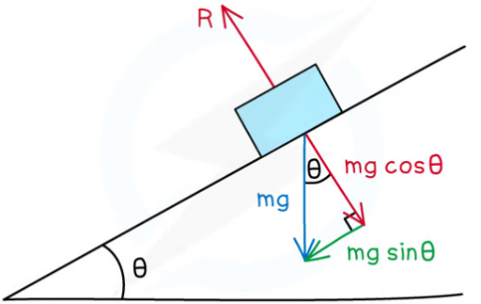
From the diagram we can see that the component of the gravitational force on the block acting in a direction parallel to the surface of the plane (‘pulling’ it down the plane) is mg sinθ

So F = ma now becomes
mg sinθ = ma or if we divide both sides by a we get
a = g sinθ

So the acceleration of the block down the plane = g sinθ
So for example if the inclined plane is at an angle of 30⁰ to the horizontal it means that the acceleration of the block down the plane $=g sin{30=\frac{g}{2}}$ = 4.9 m s⁻²

Note also that the acceleration down the plane is independent of the mass of the object – just like when we drop an object.
Thank you vectors!!

2003 Question 6 [Higher Level]
A person in a wheelchair is moving up a ramp at a constant speed.
Their total weight is 900 N.
The ramp makes an angle of 10º with the horizontal.
Calculate the force required to keep the wheelchair moving at a constant speed up the ramp.
You may ignore the effects of friction.
The key here is to remember that if an object is moving at constant speed then either no force is acting on it or (as is the case here) there are two forces acting on it which are equal in size (‘magnitude’) and opposite in direction.
We know that there is a component of gravity acting down along the plane (this is the same force that would causing a ball to accelerate down the plane) so for the wheelchair to move upwards at constant speed the upward force must equal this component of the gravitational force acting down along the plane.
But what is the size of this force?
Answer: Vectors to the rescue!

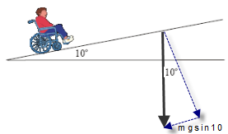
Solution
Force acting downwards parallel to the surface of the plane
$=mg\sin{θ}$ = 900 Sin 10⁰ = 156.3 N

So the force required to keep the wheelchair moving at a constant speed up the ramp must also be 156.3 N

2009 Question 6 [Higher Level]
A skateboarder with a total mass of 70 kg starts from rest at the top of a ramp and accelerates down it.
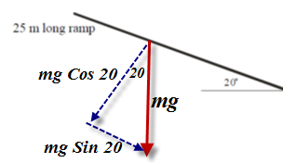
Calculate the component of the skateboarder’s weight that is parallel to the ramp.

Solution
See diagram.
Component that is parallel to the ramp = mg sin20⁰ = 234.63 N



Experiment: To find the resultant of two vectors
Procedure
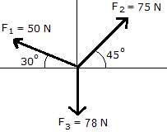
- Use cord to attach three weights to a central knot using either a force-table with pulleys as shown
Alternatively you could use three newton-meters for this.
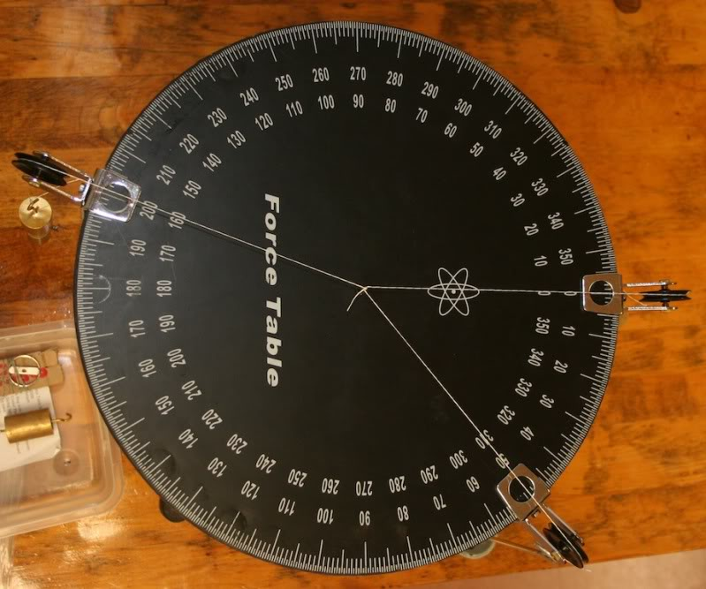

- Adjust the size and/or direction of the three forces until the central knot remains at rest.
- Read the forces and note the angles.
- Resolve any two of the forces to find out their components along the axis of the third force (see example above).
- Add both of these components to find their resultant.
- Check your answer by comparing it to the third force; it should be equal in magnitude and opposite in direction.
Example
Let’s assume we get a set of results similar to the diagram on the right hand side. We are going to calculate the vertical components of F₁ and F₂ and then compare the sum of those components to F₃.
The component of the 50 N force in the vertical direction = 50 Sin 30⁰ = 25 N (upwards)
The component of the 75 N force in the vertical direction = 75 Sin 45⁰ = 53.03 N (upwards)
F₃ = 78 N (vertical downwards).
Result
The sum of the vertical components of the first two forces is equal and opposite to the third force.

Conclusion
The sum of the components of any two of the forces along the axis of the third force is equal in magnitude but opposite in direction to the third force.

Composition (addition) of two perpendicular vectors

We saw earlier that if given a vector like the one shown (50 m s⁻¹ at an angle of 60⁰) we could resolve it into two perpendicular components to get 43 m s⁻¹ in the vertical direction and 25 m s⁻¹ in the horizontal direction.
Can we do the opposite, i.e. if given two perpendicular vectors can we represent them as one vector (called the resultant)? The number itself is known as the magnitude.

Solution
- When adding two vectors, they should be arranged tail-to-tail (the arrow represents the head) and the rectangle should then be completed.
- The resultant is the line joining the two tails to the opposite corner.
- The direction is from the tails to the opposite corner (angles usually given relative to the horizontal).
- Mathematically, the length of the vector can be found by using Pythagoras’ Theorem. 4
43² + 25² = magnitude² Magnitude = 50

- The angle can be found by using Tan θ = $\frac{opposite}{adjacent}$
So θ = Tan⁻¹ ($\frac{43}{50}$) = 60⁰

Exam question [2004]
Two forces are applied to a body, as shown.
- What is the magnitude of the resultant force acting on the body?
- What direction is the resultant force acting in?

Solution
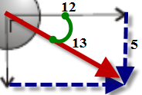
- Set up as shown
R² = 5² +12²
R = 13 N

- The direction is from the tails to the opposite corner (angles usually given relative to the horizontal).
The angle can be found by using Tan θ = $\frac{opposite}{adjacent}$
θ = tan⁻¹ $\frac{5}{12}$ θ = 22.62⁰

Worked example 2023 Question 7
A wind blows as the ball travels through the air.
The wind has a velocity of 8.2 m s^{–1} east and 3.7 m s^{–1} north.
Calculate the magnitude and direction of the velocity of the wind.
a² = b² + c²
Magnitude = v = √((8.2)² + (3.7)² = 9 m s^{–1}
Direction = tan^{–1} (opposite/adjacent) = tan^{–1} (3.7/8.2) = 24.3° North of East

Worked example 2022 Deferred Question 7

A swimmer wants to cross a river which is 75 m wide. The banks of the river are parallel.
The river is flowing with a velocity of 4 m s^{–1} parallel to the river banks, as in the diagram.
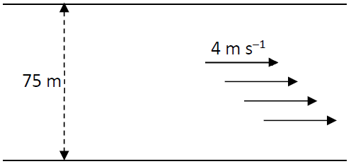

The swimmer sets out to swim across the river with a speed of 2.5 m s^{–1} perpendicular to the banks of the river.
- What is the resultant velocity of the swimmer?
This is a nice example of the power of vectors analysis. Think of the swimmer. She is aiming to go straight across and in the first second she travels 2.5 m across but in this same time she will be carried 4 m downstream by the river. This process (2.5 m across and 4 m downstream) continues until she reaches the far bank.
Her resultant velocity can therefore be calculated as follows:
Magnitude: √((2.5)² + (4)² = 4.72 m s^{–1}
Direction = tan^{–1} (4/2.5) = 58°

- How long will it take the swimmer to reach the opposite bank of the river?
Time = displacement/velocity.
The key here is to note that both vectors must be in the same direction, and given that we only have one distance (75 m) which represents the distance across the river, we therefore have to sue the velocity in this direction als (2.5 m s⁻¹).
Time = 75/2.5 = 30 s
- What will be the displacement of the swimmer from his starting position when he has reached the opposite bank?
Remember that displacement represents the straight line distance in a given direction, and in this case we are asked to calculate the straight line distance between where the swimmer started from and where she finished up.
So now we can use: displacement s = (velocity)(time).
We know the velocity in this diagonal direction is 4.72 m s⁻¹ and the time she was in the water was 30 seconds, so displacement s = 4.72 × 30 = 141.6 m

2022 Question 14 (a) [Higher level]
An object is released with an initial velocity of 150 m s^{–1} at an angle of 20° to the horizontal.

Calculate the magnitude and direction of the velocity of the object after 8 s.

Solution
First we need to resolve the initial velocity into horizontal and vertical components.
v_{Horizontal} = 150cos20° = 141 m s^{–1}

v_{vertical} = 150sin20° = 51.3 m s^{–1}

The horizontal component was initially 141 m s⁻¹ but because there is no force in the horizontal direction this doesn’t change:
v_{H} = 150cos20° = 141 m s^{–1}

However the vertical component does change and to calculate this we use v = u + at
v_{V} = 51.3 – (9.8)(8) = –27.1 m s^{–1}

So after 8 seconds our two components are:
v_{H} = 141 m s^{–1}
v_{V} = 51.3 – (9.8)(8) = –27.1 m s^{–1}

Again we use Pythagoras to find the magnitude: 141² + (27.1)² = magnitude²
Magnitude = |v| = 143.5 m s^{–1}

The angle can be found by using Tan θ = $\frac{opposite}{adjacent}$ θ = tan⁻¹ $(\frac{27.1}{141})$

θ = 10.9° [below the horizontal]

Note that the minus sign is there to indicate the direction. We can ignore it when calculating direction.

SLOP

What is a vector quantity? | A vector quantity has both magnitude and direction
What is a scalar quantity? | A scalar quantity has magnitude only
Give two examples of each. | Vector: velocity, force, displacement  Scalar: speed, distance, mass, time
Describe an experiment to find the resultant of two vectors. | See notes

The science of learning quiz: Part 13

  - Testing yourself serves two very important functions. What is the obvious one?
It identifies what you do and do not know.

  - What is the other equally important function?
You are retrieving information, which is vital for storing the information more securely in long term memory.
Why formal tests improve your memory - YouTube

  - Is it worthwhile having a nap between when you come home from school and when you start to study?
Absolutely.
It seems that your body (and brain) benefit from the ‘downtime’ and this makes the rest of your time more productive.
In one experiment scientists got two groups to learn a set of random words paired together. They allowed one group to sleep while the other watched some DVDs.
The lead scientist explained the results:
‘The control group, whose members watched DVDs while the other group slept, performed significantly worse than the nap group when it came to remembering word pairs.
The memory performance of the participants who had a power nap was just as good as it was before sleeping, that is, immediately after completing the learning phase.
Even a short sleep lasting 45 to 60 minutes produces a five-fold improvement in information retrieval from memory.”

  - What does sleep have to do with memory formation?
The part of the brain known as the hippocampus is a key part of the memory-formation process, and this only works effectively if you get a good night’s sleep. In fact much of its work on memory consolidation only takes place while you are sleeping.
The benefits of a good night's sleep. YouTube 6 mins.

Answers

  - Testing yourself serves two very important functions. What is the obvious one?
It identifies what you do and do not know.

  - What is the other equally important function?
You are retrieving information, which is vital for storing the information more securely in long term memory.
Why formal tests improve your memory - YouTube

  - Is it worthwhile having a nap between when you come home from school and when you start to study?
Absolutely.
It seems that your body (and brain) benefit from the ‘downtime’ and this makes the rest of your time more productive.
In one experiment scientists got two groups to learn a set of random words paired together. They allowed one group to sleep while the other watched some DVDs.
The lead scientist explained the results:
‘The control group, whose members watched DVDs while the other group slept, performed significantly worse than the nap group when it came to remembering word pairs.
The memory performance of the participants who had a power nap was just as good as it was before sleeping, that is, immediately after completing the learning phase.
Even a short sleep lasting 45 to 60 minutes produces a five-fold improvement in information retrieval from memory.”

  - What does sleep have to do with memory formation?
The part of the brain known as the hippocampus is a key part of the memory-formation process, and this only works effectively if you get a good night’s sleep. In fact much of its work on memory consolidation only takes place while you are sleeping.
The benefits of a good night's sleep. YouTube 6 mins.

2: CIRCULAR MOTION

Student Notes

Radians
We know that angles can be measured in degrees. They can also be measured in radians, where we define radians as follows:
$$θ= \frac{s}{r}$$
Angle (in radians) = $\frac{arc length}{radius}$

Angular velocity
Angular velocity is defined as the rate of change of angle with respect to time.
$$= \frac{}{t}$$
The symbol for angular velocity is ω (pronounced “omega”).
Angular velocity is measured in radians per second, (rad/s) or rad s⁻¹.

If an object is moving in a circle at constant speed, it is accelerating

This is because while its speed is not changing, its velocity is.
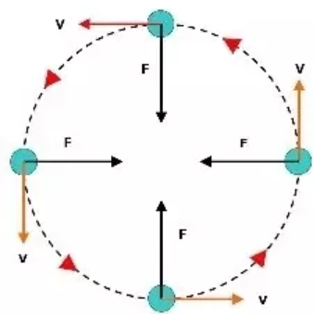
Why?
Because velocity has two components: speed and direction so even though speed is constant, the direction is not.

Why doesn’t the speed change?

Relationship between linear speed (v), angular velocity (ω) and radius
$$v= r$$

2002 Question 5 [Higher level]  A particle travels at a constant speed of 10 m s⁻¹ in a circle of radius 2 m. What is its angular velocity? | v = rω ⇒ $=\frac{v}{r}$ $=\frac{10}{2}$  ⇒ ω = 5 rad s⁻¹ towards the centre
A student swings a ball in a circle of radius 70 cm in the vertical plane as shown. The angular velocity of the ball is 10 rad s^{–1}. What is the velocity of the ball? | r = 70 cm = 0.7m  ω = 10 rad s⁻¹  v = rω = (0.70)(10) = 7.0 m s⁻¹



To derive v = rω

$$Angle (in radians)=\frac{arc length}{radius}$$
 | In symbols: $θ=\frac{s}{r}$
Now divide both sides by t | $$\frac{θ}{t}=\frac{s}{r}×\frac{1}{t}$$
Rearrange the right hand side | $$\frac{θ}{t}=\frac{s}{t}×\frac{1}{r}$$
But $\frac{θ}{t}$= ω and $\frac{s}{t}$ = v | ω = $v×\frac{1}{r}$
Multiply both sides by r to get v on its own | ⇒ rω = v

Centripetal force
The force - acting in towards the centre - required to keep an object moving in a circle is called the centripetal force.

Centripetal acceleration
If a body is moving in a circle the acceleration it has towards the centre is called centripetal acceleration.
For both of the definitions above remember to mention two things:
1. That the object is moving in a circle and
2. that the direction is in towards the centre.

Formulae for centripetal acceleration and centripetal force
$a= \frac{v^{2}}{r}$
a = rω²
but because v = rω we also have

F = mrω²
And because F = ma we get and also

And let’s throw in one more just for fun. Remember from our Waves topic that the time for one full oscillation is called the periodic time T.
The relationship between the periodic time and the angular velocity is as follows:
$$T= \frac{2π}{ω}$$

Worked example
A skateboarder of mass 70 kg has a speed of 10.5 m s^{–1} as he enters a circular ramp of radius 10 m.
What is the centripetal force acting on him?

Solution

$F_{c}=\frac{mv^{2}}{r}=\frac{(70)({10.5)}^{2}}{10}$ = 771.75 N towards the center

Circular motion exam questions: worked examples

Up to now this point whenever we have considered conservation of energy we have always used gain in kinetic energy = loss in potential energy (or vice versa). This assumes that there was only one form of energy in each position. This may not necessarily be the case. If there is more than one form of energy at a given position then we should use the following format:
Kinetic energy + potential enegy (at position 1) = kinetic energy + potential energy (at position 2)

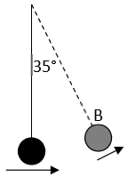
2019 Question 12 (a)
- A mass hanging at the end of a string of length 80 cm is given an initial horizontal velocity of 4 m s^{–1}.
Calculate the velocity of the mass at position B,
- Calculate its centripetal acceleration at position B.
- Draw a labelled diagram to show the forces acting on the mass when it is at position B.

Part (i) | $$h_{1}=0$$  $h_{2}=0.8-(0.8Cos 35)$ $h_{2}=0.145$ m  v₁ = 4 m s⁻¹  Kinetic energy + potential enegy (@ bottom) = kinetic energy + potential energy (@ B)  mgh₁ + ½mv₁² = mgh₂ + ½mv₂²  Divide all terms by m to get 0 + ½(v₁)² = gh + ½(v₂)²  ½(4)² = (9.8)(0.145) + ½(v₂)²  v₂ = 3.63 m s⁻¹
Part (ii) | v = 3.63 m s⁻¹  r = 0.8 m  $a=\frac{v^{2}}{r}$ $a=\frac{{3.63}^{2}}{0.8}$ a = 16.5 m s⁻² towards the centre
Part (iii) | 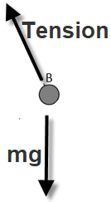  See diagram

2012 Question 12 (a)
An Olympic hammer thrower swings a mass of 7.26 kg at the end of a light inextensible wire in a circular motion. In the final complete swing, the hammer moves at a constant speed and takes 0.8 s to complete a circle of radius 2.0 m.
- What is the angular velocity of the hammer during its final swing?
- Even though the hammer moves at a constant speed, it accelerates. Explain.
- Calculate the acceleration of the hammer during its final swing
- Calculate the kinetic energy of the hammer as it is released.

Part (i)  T = 0.8 s | $T= \frac{2π}{}$ $= \frac{2π}{T}$ $= \frac{2π}{0.8}$ = 7.85 rad s⁻¹
Part (ii) | Velocity has both a speed and a direction The direction changes continuously therefore the velocity is changing so the hammer is accelerating.
Part (iii)  = 7.85 rad s⁻¹  r = 2 m | a = ω²r a = (7.85)²(2) a = 123.37 m s⁻² towards the centre of orbit
Part (iv)  m = 7.26 kg  r = 2 m  = 7.85 rad s⁻¹ | K.E. = ½ mv² K.E. = ½ m(rω) ² = ½ (7.26)[(2)(7.85)] ² K.E. = 896 J
2018 Question 6 (a)
During the discus event, Ashton swings a discus of mass 2.0 kg in uniform circular motion. The radius of orbit of the discus is 1.2 m and the discus has a velocity of 20.4 m s^{–1} when Ashton releases it.
- Calculate the angular velocity of the discus immediately prior to its release.
- Calculate the centripetal force acting on the discus just before Ashton releases it.
- In what direction does this force apply?

Part (i)  v = 20.4 m s^{–1}  r = 1.2 m | $ω=\frac{v}{r}=\frac{20.4}{1.2}$ = 17 rads s⁻¹
Part (ii)  m = 2 kg  r = 1.2 m  = 17 rad s⁻¹ | F = mrω² = (2)(1.2)(17)² = 693.6 N
Part (iii) | Towards the centre

Satellite orbits

Relationship between periodic time and radius for a satellite in orbit

Derivation of formula for periodic time of a satellite

Overall approach – find two expressions for (velocity)² and set them equal to each other

Equation 1  Compare two formulae for force which apply in satellite motion. | Equation 2  Use velocity = distance/time
The first is the universal gravitational force formula: $F_{g}=\frac{Gm_{1}m_{2}}{d^{2}}$  The fact that the satellite moves in a circle means that we can also use the centripetal force formula: $F_{c}=\frac{mv^{2}}{r}$  Equate both expressions for force:  Centripetal force = gravitational force  $$\frac{mv^{2}}{r}=\frac{Gm_{1}m_{2}}{d^{2}}$$  Cancel one ‘m’ from both sides  Replace the d² in the second formula with r² (both represent the same thing) and final cancel one ‘r’ on both sides  $v^{2}=\frac{GM}{R}$  We now have Equation (1)  Eq | $$velocity=\frac{distance}{time}$$  Distance in this case is the circumference of a circle (2πR for circular satellite orbits)  ⇒ $v=\frac{2πR}{T}$ ⇒  $v^{2}=\frac{4π^{2}R^{2}}{T^{2}}$ Equation (2)
Equating equations (1) and (2) we get $\frac{4π^{2}R^{2}}{T^{2}}$ = $\frac{GM}{R}$

And finally we cross-multiply to get $T^{2}=\frac{4π^{2}R^{3}}{GM}$

Note that most (but not all) equations are either on the gravity page or on the circular motion page of the Formula & Tables book.
The following is probably the most relevant in relation to exam questions and for some reason is NOT in the F&T book: $v^{2}=\frac{GM}{R}$

2014 Question 5 [Higher level]  The Martian moon Phobos travels in a circular orbit of radius 9.4 × 10⁶ m around Mars with a period of 7.6 hours.  Calculate the mass of Mars.  Solution  T = 7.6 hours = (7.6)(60)(60) seconds  r = 9.4 × 10⁶ m | $T^{2}=\frac{4π^{2}R^{3}}{GM}$ $M=\frac{4π^{2}R^{3}}{GT^{2}}$  $M=\frac{4π^{2}({{9.4 × 10}^{6})}^{3}}{(6.7 x {10}^{-11})(7.6{ ×60×60)}^{2}}$  M = 6.538 × 10²³ kg
2004 Question 12 (a) [Higher level]
- Centripetal force is required to keep the earth moving around the sun.
What provides this centripetal force?
- In what direction does this centripetal force act?
- Give an expression for centripetal force.
- The earth has a speed of 3.0 × 10⁴ m s^{–1} as it orbits the sun.
The distance between the earth and the sun is 1.5 × 10¹¹ m. Calculate the mass of the sun.
(gravitational constant G = 6.7 × 10^{–11} m³ kg^{–1} s^{–2})

Part (i) | Gravitational pull of the sun.
Part (ii) | Towards the centre.
Part (iii) | $F_{c}=\frac{mv^{2}}{r}$
Part (iv)  r = 1.5 × 10¹¹ m  v = 3.0 × 10⁴ m s^{–1}  G = 6.7 × 10^{–11} m³ kg^{–1} s^{–2} | $v^{2}=\frac{GM}{R}$ $M_{sun}=\frac{Rv^{2}}{G}$  $M_{s}=\frac{{(1.5 ×{10}^{11})(3.0 ×{10}^{4})}^{2}}{6.7 × {10}^{-11}}$ M_{s} = 2.0 × 10³⁰ kg.

- Parts of the South Pacific are so remote that the nearest humans are the astronauts passing 408 km overhead on the International Space Station.

- Heavens-above.com is a very cool website with real-time updates on satellites visible from your home.

Geostationary Satellites

These are satellites which remain over one position of the Earth (hence the name), their orbit is called a geostationary orbit.
We know that if we want a satellite to remain over a specific spot on the Earth’s surface it must have the same periodic time as the Earth (24 hours). The formula above allows us to calculate the height which the satellite must be at (approx. 36,000 km above the equator) in order to have a periodic time of 24 hours.

2013 Question 6 [Higher level]
The International Space Station (ISS) orbits the earth at an altitude of 4.13 × 10⁵ m every 92 minutes 50 seconds.
- Calculate (a) the angular velocity, (b) the linear velocity, of the ISS.
- Name the type of acceleration that the ISS experiences as it travels in a circular orbit around the earth.
- What force provides this acceleration?
- Calculate the attractive force between the earth and the ISS.
- Hence or otherwise, calculate the mass of the earth.
- If the value of the acceleration due to gravity on the ISS is 8.63 m s⁻², why do occupants of the ISS experience apparent weightlessness?
- What is the period of a geostationary communications satellite?
(mass of ISS = 4.5 × 10⁵ kg; radius of the earth = 6.37 × 10⁶ m)

Part (i) | It takes the ISS 92 minutes 50 seconds to do one complete orbit.  This corresponds to the periodic time T, but we need to convert it into seconds.  T = 92 minutes 50 seconds = 5570 seconds  $ω= \frac{2π}{T}= \frac{2π}{5570}$ = 1.1 × 10⁻³ rad s⁻¹  v = rω  r in this context corresponds to the distance between the ISS and the centre of the Earth  r = radius of the Earth plus height of the ISS above the surface of the Earth.  r = (6.37 × 10⁶) + (4.13 × 10⁵) = 6.783 × 10⁶  v = rω  v = (6.783 × 10⁶)(1.1 × 10⁻³) = 7651.5 m s⁻¹
Part (ii) | Centripetal
Part (iii) | Gravitational force (note that you can’t use the word ‘gravity’)
Part (iv) | {We don’t have enough information to use Newton’s gravitational law, but we can use the fact the ISS is travelling in a circular orbit, and so use the equation for centripetal force; $F_{c}=\frac{mv^{2}}{r}$  ‘m’ in this context corresponds to the mass of the orbiting body, and we were told in the question that the mass of the ISS is is 4.5 × 10⁵ kg}  $F_{c}=\frac{({4.5×10}^{5})({7651.5)}^{2}}{{6.783 × 10}^{6}}$ F = 3.884 × 10⁶ N
Part (v) | Hence or otherwise, calculate the mass of the earth.  $v^{2}=\frac{GM}{r}$ $M=\frac{rv^{2}}{G}$ $M=\frac{(6.783 × {10}^{6})({7651.5)}^{2}}{6.7×{10}^{-11}}$  M = 5.95 × 10²⁴ kg
Part (vi) | They are in freefall // ISS accelerating at the same rate as occupants
Part (vii) | One day

Background reading

Conservation of angular momentum – not on the syllabus, but interesting nevertheless.
You have noticed that when a figure dancer on the ice rink pulls in her arms, her body spins more quickly.
This is because angular momentum involves the product of radius and angular velocity; if the radius decreases the angular velocity must increase in order for the angular momentum to remain constant.

This can also be demonstrated by sitting on a rotatable seat and having someone spin you around while your arms are outstretched.
Now bring in your arms – you speed up!
The effect is more noticeable if you hold a heavy weight (a barbell or a book) in each hand. But be careful!

The most amazing example of this is neutron stars.
These are stars which are three or four times the mass of our sun, but only a fraction of the size. Because their radii have decreased so much, their spin-rate must increase accordingly –some stars carry out a full revolution in a thousandth of a second!

This led to discovery of pulsars by the Irish astronomer Dame Jocelyn Bell Burnell, who initially thought the regular pattern of electromagnetic signals being emitted from these rapidly rotating “pulsing stars” (pulsars) might be due to an alien life-form (she didn’t take the possibility too seriously).
She did however call the first pulsars LGM1 and LGM2 (LGM standing for ‘Little Green Men’).
It’s considered by many to have been a travesty that she never received a Nobel Prize for her discovery. Strangely enough, her supervisor did receive a Nobel Prize for the same achievement. The bit I find strangest about all of this is that Dame Jocelyn Bell Burnell herself is not in the least bit bitter about this and in fact in a recent interview declared that she is quite relieved not to have received the award. We revisit this on our chapter on Atomic Physics.

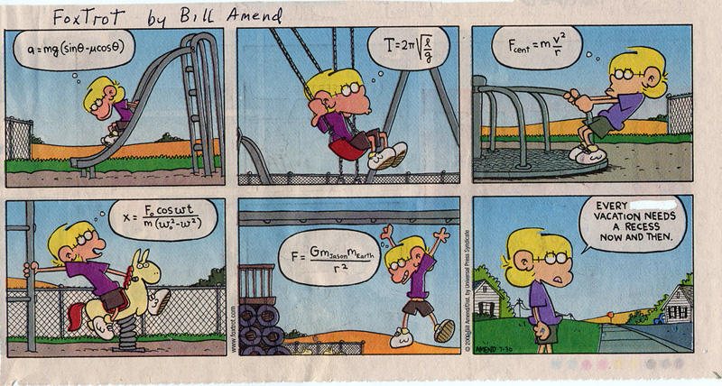

The most important lesson you will learn today - Whitey On the Moon

Check it out on YouTube to hear it performed by the author; poet and singer Gil Scott-Heron

A rat done bit my sister Nell.
(with Whitey on the moon)
Her face and arms began to swell.
(and Whitey's on the moon)

I can't pay no doctor bill.
(but Whitey's on the moon)
Ten years from now I'll be payin' still.
(while Whitey's on the moon)

The man jus' upped my rent las' night.

('cause Whitey's on the moon)
No hot water, no toilets, no lights.
(but Whitey's on the moon)

I wonder why he's uppi' me?
('cause Whitey's on the moon?)
I was already payin' 'im fifty a week.
(with Whitey on the moon)

Taxes takin' my whole damn check,
Junkies makin' me a nervous wreck,
The price of food is goin' up,
An' as if all that shit wasn't enough
A rat done bit my sister Nell.
(with Whitey on the moon)

Her face an' arm began to swell.
(but Whitey's on the moon)
Was all that money I made las' year
(for Whitey on the moon?)

How come there ain't no money here?
(Hm! Whitey's on the moon)
Y'know I jus' 'bout had my fill
(of Whitey on the moon)

I think I'll sen' these doctor bills,
Airmail special
(to Whitey on the moon)

Centripetal motion

One of the greatest misconceptions in all of science is to with circular motion, and that’s one reason why many students don’t like this chapter.

Consider the image below of the stone moving in a circular path (you have to imagine that you are looking down on this from above).
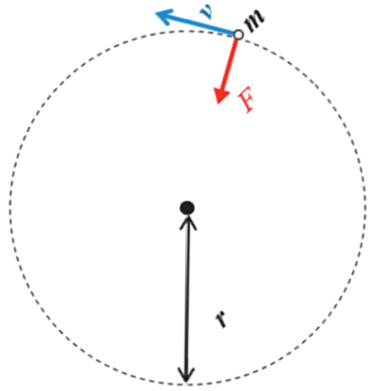
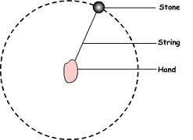

If the stone is to around in a circle it must have a force pulling it inwards towards the centre of the circle, in this case that force is the tension in the string. If the string was suddenly cut, the stone would fly off in a straight line in a direction tangential to the circle (in the direction of v in the second diagram).
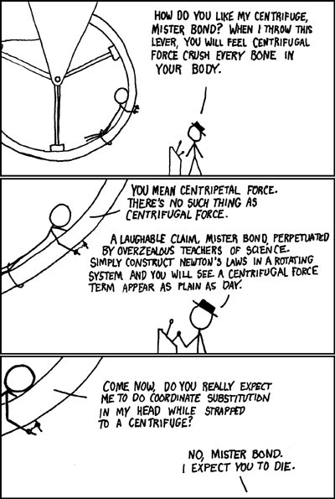
The force towards the centre is called the centripetal force but – and here’s the important bit – what causes this centripetal force will change from situation to situation. It might be tension in a string or it could be the force of gravity or even friction (in the case of a car going around a bend).

The confusion that arises here is that students (and teachers?) think that the centripetal force is a type of force – it’s not; it’s just a name given to any force that causes an object to move in a circle. Because of this confusion I try to avoid referring to it at all.

Sometimes reference is made to a centrifugal force – a force that seems to be acting outwards on an object travelling in a circle but there is no such force. When going around a bend in a car, I experience a force that I think is pushing me outwards when in fact it is an inward (contact) force between me and the car door and if it didn’t exist I would fly off like the stone when the sting is cut in the previous example.
So for the diagram above many (most?) students would put in three forces; gravity (acting downwards), tension (acting in towards the centre) and a centrifugal force acting outwards. Hopefully by now you will see that the centrifugal force does not exist.

Xkcd.com/123

*Relationship between periodic time and radius for a satellite in orbit
Congratulations
You have just arrived at an equation which bookmarks a seminal moment in the history of science.

Around this time (late16th century) an astronomer called Johannes Kepler discovered empirically (i.e. by analyzing data on the motion of planets) that the square of the periodic time of these planets (time for one complete orbit around the sun) is proportional to the cube of their distance from the sun.
Kepler actually stole the necessary data from a colleague, Tycho Brahe, but that’s nothing new in the world of Science. We will conveniently ignore that for now.
Later on Newton came along and was able to demonstrate this relationship mathematically, by combining a well-known equation for circular motion on Earth $F_{c}=\frac{mv^{2}}{r}$ with his own universal law of gravitation. $F_{g}=\frac{Gm_{1}m_{2}}{d^{2}}$

We are about to follow in his footsteps and see exactly what he did and how he did it. Do not under-estimate the importance of this exercise (yes you have to know it for exam purposes, but that’s not why I consider it important).
This event had two very important consequences.
- It showed that Newton’s law of gravitation must be valid in its own right, which was very important in securing Newton’s reputation as a giant of science, both at the time and for posterity.
- Even more importantly, it demonstrated that ‘the heavens’ followed the same rules of science as those which operated here on Earth.
This meant that they were a legitimate area of study, and so Astronomy (which in turn led to Cosmology) was given an added respectability. Just to give a sense of what people believed at the time, Kepler had to spend much of his time during this period defending his mother of charges of being a witch.

I can think of no modern discovery which compares with this. Even if we discovered life on Mars it really wouldn’t be that big a deal. Up to this point the heavens were considered off-limits; the realm of God or the gods or whatever you’re into yourself. But now they could be shown to be just another series of objects which followed set rules, much like cogs in a complicated clock. So God was being pushed into the wings. You could see why neither Martin Luther or the Vatican Church would have been keen fans.
Kepler was following on the work of Nicolas Copernicus (known to science students down the ages as ‘copper knickers’), who in turned showed that the Earth revolved around the Sun, not the other way around.
Galileo’s run in with the Church was because he supported Copernicus’ view, so Galileo never actually made that discovery, but he was happy to use it to make fun of the church authority figures of the time. And we all know how that worked out for him.
So this was really the dawn of science, and progress was hindered by medieval views of the astronomers themselves. It took Kepler decades to realise that the orbit of the planets was elliptical in nature, not circular. He had assumed initially that the motion had to be circular because a circle was a perfect shape (harping back to the teachings of Pythagoras and Aristotle, among others) and therefore would have been more pleasing to God who obviously had created the planets in the first place.
Similarly Newton, despite being heralded as one of our greatest ever scientists, spend up to 90% of his time trying to date the creation of Earth by tracing who gave birth to who in the bible.
But then Newton had another problem. He realised that Kepler was correct in stating that the planets traced out elliptical orbits, but even Newton’s equations didn’t fully match the path of the heavenly bodies; according to Newton’s equations the planets should slowly but execrably drift from their current pathways. He couldn’t figure out why this didn’t happen – after all, his equations seemed to be perfect in every other way. And Newton believed that he was getting his ideas directly from God. Which doesn’t leave much room for admitting you made a mistake.

We now know that while Newton’s equation are very accurate, we actually need Einstein’s Theory of General Relativity to explain why they don’t precisely describe the motion of the planets.
It’s interesting to note that Newton’s explanation was that God must step in every so often to gently nudge the planets back into their preferred orbits. Now as you now know, invoking a deity to explain discrepancies in scientific observations is the antithesis of Science. So perhaps Newton wasn’t actually so mighty after all. This is partly why he is sometimes referred to as the last sorcerer rather than the first scientist.
So now we’re up to Einstein. His general theory of relativity suggested that the universe was expanding, but just like all of his predecessors he was a man of his time, and this coloured how he saw the world. It was believed at the time that the universe has always been the way it is now (this is referred to as the ‘Steady State’ theory). Einstein figured that there must be some mistake in his paper so he introduced what he called a ‘cosmological constant’ which basically amounted to a fudge factor which altered the implications of his calculations and prevented the universe from expanding.

Which was all very well until Hubble (he of the ‘Hubble’ telescope) showed that the universe was actually expanding after all.

Doh!
Einstein referred to this as his greatest ever blunder.

So there you have it. This has been my attempt to put some context on the derivation that we are about to carry out. It is our chance to repeat one of the greatest moments in the history of science.
So you have two options; you can consider this exercise to be a pain in the ass or you consider it an incredible privilege to be in a position where you can follow in the footsteps of giants.
I think we know which option I go with.
And don’t be afraid to tell your parents this tonight; they may well throw their eyes up to heaven but if they do that’s a slight on them – not on you.


SLOP

G = 6.7 × 10⁻¹¹ N m² kg⁻², Radius of Earth = 6.4 × 10⁶ m,
Mass of Earth = 6 × 10²⁴ kg. Mass of the sun = 2 × 10³⁰ kg. Mass of Saturn = 5.7 × 10²⁶ kg.
Mean distance of Saturn from the Sun = 7.8 × 10¹¹ m.

Define angular velocity. | Angular velocity is the rate of change of angle with respect to time.
Derive the relationship between the velocity of a particle travelling in uniform circular motion and its angular velocity. | θ = s /r  ⇒ θ /t = s/rt  ⇒ ω = v /r  ⇒ v = ω r
Define centripetal force. | The force - acting in towards the centre - required to keep an object moving in a circle is called Centripetal Force.
Give an expression for centripetal force.
- Centripetal force is required to keep the earth moving around the sun.  What provides this centripetal force?  - In what direction does this centripetal force act? | - Gravitational pull of the sun.  - Towards the centre.
The moon orbits the earth. What is the relationship between the period of the moon and the radius of its orbit? | $$T^{2}=\frac{4π^{2}R^{3}}{GM}$$
Derive the relationship between the period of the ISS, the radius of its orbit and the mass of the earth. | See notes

The science of learning quiz: Part 14

- Is it worthwhile spending time on exercise (between when you come home from school and when you start to study)?

- Homework can be (roughly) divided into two types.
Name them and state how you would distinguish one from the other.

- Why is ‘prep’ (it tends to be a word associated with the British education system) an effective exercise?

Answers

- Is it worthwhile spending time on exercise (between when you come home from school and when you start to study)?
Yes. It may seem rather odd, but there is actually a lot of research which highlights that exercise plays a very important role here, although scientists are still not sure why (it may be that the heart is pumping more blood around the body, including the brain, and this effect is still noticeable even after the exercise has stopped).

- Homework can be (roughly) divided into two types.
Name them and state how you would distinguish one from the other.
Busy homework and effective homework
Effective homework will involve developing or practicing a skill learned in class (eg learning to use a new word in the correct context) or some form of elaborative interrogation. Busy homework is doing just that; merely keeping you busy. Busy homework could be done while watching The Simpsons because there is no learning going on anyway.

- Why is ‘prep’ (it tends to be a word associated with the British education system) an effective exercise?
Presumably because it should be work that prepares you for the next class. Currently many teachers just give homework based on what happened in that day’s class. Preparatory work might involve looking over the next day’s material in advance, resulting in the student being much more engaged and ready to ask questions about those concepts which didn’t make sense during the preview. It is a very effective exercise but unfortunately one which we don’t invoke nearly as often as we should.

3: SIMPLE HARMONIC MOTION AND HOOKE’S LAW

Student Notes

Simple harmonic motion (S.H.M.)

An object is said to be moving with simple harmonic motion if the object’s acceleration towards a fixed point is directly proportional to its displacement from the fixed point.

We represent this mathematically as a = -k x

In this case the proportional constant is ω².
a = -ω² x
So our mathematical representation of SHM becomes

- The ‘fixed point’ referred to in the definition is also called the ‘equilibrium position’.
- The key to SHM is that the acceleration and the displacement are always opposite in direction.
- This is represented by the minus sign in the equation, although mathematically the minus sign has no significance and can be ignored for calculations.

Other examples of SHM, apart from a stretched string are
- A prong on a vibrating tuning fork
- A pendulum oscillating at a small angle

Displacement, velocity, acceleration and force for an object undergoing SHM

Let’s take a look at these on a diagram.
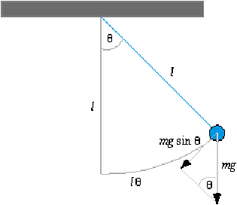
 | Equilibrium  position | Extreme  position
Displacement | 0 | max
Velocity | max | 0
Acceleration | 0 | max
Force | 0 | max

Draw a diagram similar to above but with forces and also to show relationship between omega for both circular motion and shm

The aspect which most people find confusing here is that at the extremities the velocity is zero while the acceleration is a maximum, whereas at the equilibrium position the opposite is the case.
How can this be?

Answer
You must think in terms of forces
After all, the only way you can have acceleration is if you have a (net) force causing it.
Acceleration is directly proportional to the force causing it, so if force is a maximum acceleration must be also, and vice versa. Now let’s look at the diagram above in terms of forces.
At the equilibrium point the restoring force on the mass is zero – it’s not being pulled to the left or the right, therefore the acceleration must be zero, whereas at the extremities the force pulling the mass back in is a maximum, therefore the corresponding acceleration must also be also be a maximum.

The other point which might cause confusion is velocity being zero at the extreme positions, but remember we came across this before; when an object is thrown up its instantaneous velocity is zero at the very top, (even though its acceleration is not zero).

Relationship between T and ω for an object undergoing SHM

As with the Waves and Circular Motion topics the periodic time (T) is the time taken for one complete oscillation.
$$T= \frac{2π}{}$$

The frequency of a wave refers to the numbers of oscillations per second.
Relationship between periodic time and frequency: $T= \frac{1}{f}$ or $T= \frac{1}{f}$

2014 Question 12 (a)
Sketch a velocity-time graph of the motion of the object undergoing simple harmonic motion

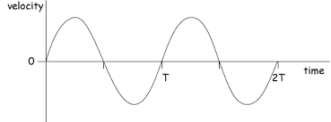
Solution

2011 Question 12 (a)
A body of mass 250 g vibrates on a horizontal surface and its motion is described by the equation a = – 16 s, where s is the displacement of the body from its equilibrium position.
The amplitude of each vibration is 5 cm.
- Why does the body vibrate with simple harmonic motion?
- Calculate the frequency of vibration of the body?
- What is the magnitude of (i) the maximum force, (ii) the minimum force, which causes the body’s motion.

Part (i) | ‘Why’ questions always difficult to answer – in this case the examiner is asking you ‘what is it about the format of the equation a = – 16 s that tells us that this motion is simple harmonic?’  Answer  The equation a = – 16 s shows that the acceleration is proportional to the displacement and equations of this format describe simple harmonic motion.
Part (ii) | The general expression for simple harmonic motion is a = – $ω$ ²s.  The equation in this question is a = – 16 s  Therefore we can assume that ω² = 16 and so ω = 4  $T=\frac{2π}{ω}$ and f = $\frac{1}{T}=$ $\frac{ω}{2π}$ Therefore f = $\frac{ω}{2π}$= $\frac{4}{2π}$ = 0.64 Hz  Note that we can ignore the negative sign in the equation a = – $ω$ ²s.  It is there to reflect that the acceleration and displacement are opposite in direction.
Part (iii) | a = $ω$ ²s.  F_{max} occurs when acceleration is a maximum which according to our equation occurs when displacement (s) is a maximum.  Maximum displacement = amplitude = 5 cm = 0.05 m  a_{max} = (16)(0.05) = 0.80  F_{max} = (m)(a_{max}) = (0.250)(0.80) = 0.20 N  The minimum force occurs when displacement is 0, so acceleration is 0, so F_{min} = 0

Hooke’s law

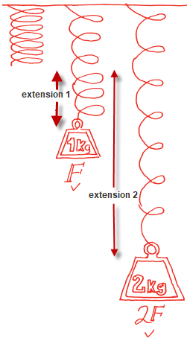
Hooke’s law states that when a force is exerted to extend or compress a spring, the restoring force is proportional to the displacement.

We represent this mathematically as follows:

F ∝ - extension ⇒
F = - k (extension) or F = -ks

Where k is referred to as the spring constant and s = extension

The “minus’ signifies that the restoring force and the extension (or compression) are opposite in direction.
The most common example of Hooke’s Law is a stretched string.
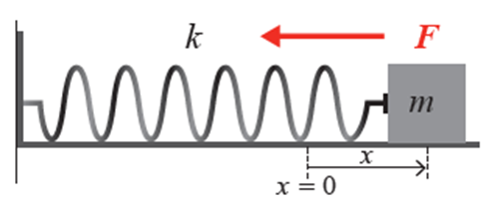

To show that any object that obeys Hooke’s Law will also execute SHM

The aim here is to show that Hooke’s Law is a subset of S.H.M., i.e. that F ∝ -s can be rewritten in the form a = - ω² s where ω is simply a constant of some form.

So we start with the equation for Hooke’s Law: F ∝ -s ⇒ F = -k s
But F = ma ⇒ ma = -k s
$$a= -\frac{k}{m} s$$
Now divide both sides by m ⇒

So we have an expression where a ∝ -s, therefore it represents simple harmonic motion.

Introduction to SHM & Hooke’s law maths questions

- Compare the equation $a= -\frac{k}{m} s$ to the general expression for simple harmonic motion $a= -ω^{2} s$
we get $\frac{k}{m}= ω^{2}$ or $ω= \sqrt{\frac{k}{m}}$
$$ω= \sqrt{\frac{k}{m}}$$

This relationship is used in ALL the long exam questions below

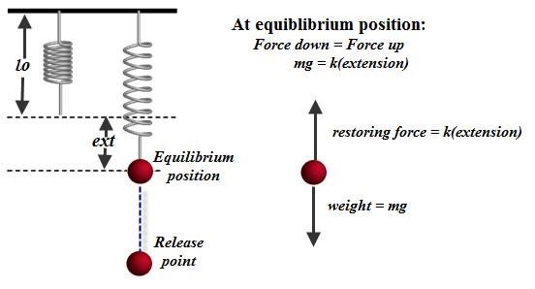
- At equilibrium position: mg = k(extension)
Explanation
At point of equilibrium force down = force up.
The force down is just the force of gravity:
mg
The force up is due to the stretched string so we invoke Hooke’s Law to describe it:
F = k (extension)
So we have mg = k(ext).

- You will either be given k and have to find the extension or else you will be given the extension and have to find k.

- When using the F = -k (extension) equation for Hooke’s Law, the extension is the distance between the new length and the original (natural) length.

- When using the expression for simple harmonic motion (a = -ω² s) s represents the distance between the new length and the equilibrium position.

$$T=\frac{2π}{ω}$$ | $$T=\frac{1}{f}$$

- Other relevant equations:

- And one more time: Your first line will be to note that at equilibrium position: mg = k(extension) so start with this and use it to find either the spring constant k or the extension.

2020 Question 5  A spring has a length of 22 cm when a 2 N weight hangs from it.  The spring constant is 50 N m^{–1}.  Calculate the natural length of the spring. | The weight is hanging so we assume equilibrium position and can use Force down = Force up  k = 50 N m^{–1}  Force down = weight = 2 N  Force up =tension on the string = k(extension)  Force down = Force up  2 = 50(extension)  Extension = 0.04 m = 4 cm  22 cm corresponds to the length of the spring when it is extended by 4 cm.  Natural length = 22 cm – 4 cm = 18 cm.

2014 Question 12 (a)
The elastic constant of a spring is 12 N m^{–1} and it has a length of 25 mm.
An object of mass 20 g is attached to the spring.
- What is the new length of the spring?
- The object is then pulled down and released so that it oscillates with simple harmonic motion. Calculate the period of oscillation of the object.

Part (i)  k = 12 N m^{–1}  l₀ = 25 mm = 0.025 m  m = 0.02 kg | What is the new length of the spring?  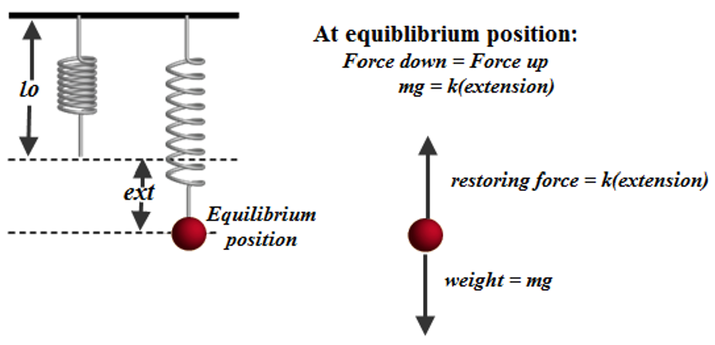  After the mass has been attached it will come to rest at a new equilibrium position (E.P.) where force down = force up  force down = mg = (0.02)(9.8)  force up = k(extension)  force down = force up  0.02(9.8) = 12(extension)  0.196 = 12(extension)  extension = 0.0163 m  New length = 0.025 + 0.0163 = 0.0413 m
Part (ii) | $T=\frac{2π}{ω}$, so first we need to calculate $ω$.  $ω=\sqrt{\frac{k}{m}}=\sqrt{\frac{12}{0.02}}$ $ω=$ 24.5 s⁻¹  $$T=\frac{2π}{ω}=\frac{2π}{24.5}$$  T = 0.256 s

2021 Question 14 (a)
An iron sphere of mass 40 g hangs from a spring and oscillates with simple harmonic motion.
The period of oscillation is 0.74 s.
- Calculate the spring constant.
- Calculate the acceleration of the sphere when its displacement is 18 mm from its equilibrium position.

- The iron sphere and the spring are brought to rest and a small magnet is attached to the sphere.
When the magnet is attached to the sphere, the length of the spring increases by 15 mm.
Calculate the mass of the magnet.

Part (i)  T = 0.74 s.  m = 0.04 kg | $T=\frac{2π}{ω}$ $0.74=\frac{2π}{ω}$ $ω=\frac{2π}{0.74}$ ω = 8.49 s⁻¹  $ω=\sqrt{\frac{k}{m}}$ $ω^{2}=\frac{k}{m}$ ${8.49}^{2}=\frac{k}{0.040}$ k = 2.88 N m⁻¹
Part (ii)  ω = 8.49 s⁻¹  s = 0.018 m | a = ω²s a = (8.49)²(0.018) a = 1.3 m s⁻²
Part (iii)  k = 2.88 N m⁻¹  Extension = 15 mm  = 0.015 m | Force down = Force up  mg = k (extension)  (m)(9.8) = (2.88)(0.015)  m = 0.0044 kg  Note: it doesn’t help that there are two masses in this question. The mass relevant to part (iii) is just the mass associated with causing the extension so we ignore the mass of the sphere for this section.

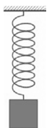
2022 Question 7
A spring of natural length 150 mm obeys Hooke’s law.
When an object of mass 200 g is attached to it, the length of the spring increases to 185 mm.
- Calculate the elastic constant of the spring.
- The object is pulled down until the spring has a length of 200 mm.
The object is then released. It moves with simple harmonic motion.
Calculate the period of oscillation of the object.
- Calculate the maximum acceleration of the object.
- What is the speed of the body when it has maximum acceleration?

Part (i)  New length = 0.185 m  Original length = 0.150 m  m = 0.2 kg | Force down = Force up  mg = k (extension)  (0.2)(9.8) = (k) (0.185 – 0.15)  k = 56 N m^{–1}
Part (ii)  m = 0.2 kg  k = 56 N m^{–1} | $T=\frac{2π}{ω}$ so we first need to find ω  $ω=\sqrt{\frac{k}{m}}$ $ω=\sqrt{\frac{56}{0.2}}$ ω = 16.73 s^{–1}  $T=\frac{2π}{ω}$ $T=\frac{2π}{16.73}$ T = 0.375 s
Part (iii)  ω = 16.73 s^{–1} | Remember that when using the expression a = -ω² s, s represents the distance between the new length and the equilibrium position.  Secondly, acceleration is proportional to displacement so acceleration will be a maximum when displacement is a maximum.  Maximum displacement = (0.2 – 0.185)= 0.015 m  a = –ω²x  a_{max} = (280)(0.015) = 4.2 m s^{–2}
Part (iv) | What is the speed of the body when it has maximum acceleration?  The object has maximum acceleration at the extreme position, which is also where the velocity is zero.

Periodic time of a simple pendulum

A simple pendulum consists of a light string with a mass at the end.

$$T=2π\sqrt{\frac{l}{g}}$$

2022 Question 6 Deferred Exam Higher Level
Calculate the length of a pendulum that has a period of one second.

$T=2π\sqrt{\frac{l}{g}}$ $T^{2}=\frac{4π^{2}l}{g}$ $l=\frac{gT^{2}}{4π^{2}}$ $l=\frac{(9.8)(1)}{4π^{2}}$ l = 0.248 m

INVESTIGATION OF THE RELATIONSHIP BETWEEN T AND l FOR A PENDULUM

APPARATUS
Pendulum bob, split cork, ruler, string and timer

DIAGRAM

PROCEDURE
- Place the thread of the pendulum between two halves of a cork or between two coins and clamp to a stand.

- Measure length (l) from fixed point to top of bob (using metre stick).
- Measure the diameter of the bob using a digital calipers and calculate the radius (r).
- Total length = l + r

- Set the pendulum swinging through a small angle (<10°).

- Measure the time t for thirty complete oscillations.

- Divide this time t by thirty to get the periodic time T.

- Repeat for different lengths of the pendulum.

- Draw a graph of T² against length l and use the slope to calculate a value for g ( g = 4π²/slope).

RESULTS
length (m)
time for 30 oscillations (s)
time for 1 oscillation (s)
T² (s²)

CONCLUSION
We got a value for g to be 9.7 N kg⁻¹, which compares favourably with the theoretical value of 9.8 N kg⁻¹. We therefore conclude that the theory may well be correct.

SOURCES OF ERROR / PRECAUTIONS
- Measuring from the bottom of the split-cork to the centre of the bob.
- Do not cause the pendulum to swing through an angle greater than approximately 10 degrees.
- Ensure that the pendulum swings in one plane only - avoid circular movements.
- Have the pendulum as much as possible to minimise percentage errors associated with measuring the length and also the time.

Theory questions

Why did the student measure the time for 30 oscillations instead of measuring the time for one?

How did the student ensure that the length of the pendulum remained constant when the pendulum was swinging?
Between which points was the length of the pendulum measured? | from fixed point to centre of bob (using metre stick)
Describe how the student obtained a value for the length of the pendulum and its corresponding periodic time. | Measure length (l) from fixed point to top of bob using metre stick  Measure diameter/radius using a digital calipers  Length = l + r
Describe how the student obtained a value for the corresponding periodic time. | Measure time for n oscillations  Divide total time by n
Using the recorded data draw a suitable graph to show the relationship between the period and the length of a simple pendulum. | Graph of T² (vertical axis) against length (horizontal axis).
What is this relationship? | T² is proportional to length.
Justify your answer. | Straight line through the origin
Use your graph to calculate the acceleration due to gravity. | slope calculated using two points on line  substitute into formula $T^{2}=\frac{4π^{2}}{g}l$  g ≈ 9.8 m s⁻²
Give two factors that affect the accuracy of the measurement of the periodic time. | Number of oscillations selected / the precision of the timer / repetition (of measurement for average) / smaller % error in T with longer lengths / nature of the string e.g. ‘inextensible string’
Explain why a small heavy bob was used. | To reduce air resistance and to keep the string taut
Why did the student use a small angle? | Formula is valid only for a small angle / SHM occurs only for a small angle
Explain why the string was inextensible. | So that length remains constant because length would be another variable and we can only investigate between any two variables at a time.
How did the student ensure that the pendulum was suspended from a fixed point? | She suspended it in a split cork / between two coins
Between which points was the length of the pendulum measured? | Between the bottom of the cork/coins and the middle of the bob
Which t value is most accurate? | The one corresponding to the longest length
Explain your answer. | Smallest percentage error associated with measuring length and time.

Exam questions
HL: 2017, 2012, 2008, 2006

[2012]
In an experiment to measure the acceleration due to gravity using a simple pendulum, a student obtained values for the length l of the pendulum and the corresponding values for the periodic time T.
The student plotted the following points, based on the recorded data.

- Describe how the student obtained a value for the length of the pendulum and its corresponding periodic time.
- Draw the appropriate graph on this examination paper and use it to calculate a value for g, the acceleration due to gravity.
- Give two factors that affect the accuracy of the measurement of the periodic time.

[2008]
A student investigated the relationship between the period and the length of a simple pendulum. The student measured the length l of the pendulum.
The pendulum was then allowed to swing through a small angle and the time t for 30 oscillations was measured.
This procedure was repeated for different values of the length of the pendulum.
l /cm | 40.0 | 50.0 | 60.0 | 70.0 | 80.0 | 90.0 | 100.0
t /s | 38.4 | 42.6 | 47.4 | 51.6 | 54.6 | 57.9 | 60.0
The student recorded the following data:

- Why did the student measure the time for 30 oscillations instead of measuring the time for one?
- How did the student ensure that the length of the pendulum remained constant when the pendulum was swinging?
- Using the recorded data draw a suitable graph to show the relationship between the period and the length of a simple pendulum.
- What is this relationship?
- Use your graph to calculate the acceleration due to gravity.

[2006]
In investigating the relationship between the period and the length of a simple pendulum, a pendulum was set up so that it could swing freely about a fixed point.
The length l of the pendulum and the time t taken for 25 oscillations were recorded.
This procedure was repeated for different values of the length.
l/cm | 40.0 | 50.0 | 60.0 | 70.0 | 80.0 | 90.0 | 100.0
t/s | 31.3 | 35.4 | 39.1 | 43.0 | 45.5 | 48.2 | 50.1
The table shows the recorded data.
The pendulum used consisted of a small heavy bob attached to a length of inextensible string.
- Explain why a small heavy bob was used.
- Explain why the string was inextensible.
- Describe how the pendulum was set up so that it swung freely about a fixed point.
- Give one other precaution taken when allowing the pendulum to swing.
- Draw a suitable graph to investigate the relationship between the period of the simple pendulum and its length.
- What is this relationship? Justify your answer.

Solutions

2012
Length (m) | 0.43 | 0.62 | 0.75 | 0.78 | 0.91 | 1.05
T²/s² | 1.8 | 2.46 | 2.98 | 3.15 | 3.68 | 4.14
- Correct method for slope (–1 if (0,0) chosen as point on graph)
- Slope: 3.47 $≤$ m $≤$ 4.14
- g = 9.5 $≤$ g $≤$ 11.0 m s^{–2}
2008
l /cm | 40.0 | 50.0 | 60.0 | 70.0 | 80.0 | 90.0 | 100.0
time for 30 oscillations | 38.4 | 42.6 | 47.4 | 51.6 | 54.6 | 57.9 | 60.0
Time for 1 oscillation
t²/ s²
l/m | .40 | .50 | .60 | .70 | .80 | .90 | 1.00 | l/m
g = 9.72 m s^{–2} [range: 9.4 – 9.9 m s^{–2}]
2006
l/cm | 40.0 | 50.0 | 60.0 | 70.0 | 80.0 | 90.0 | 100.0
Time for 25 swings /s | 31.3 | 35.4 | 39.1 | 43.0 | 45.5 | 48.2 | 50.1
Time for 1 oscillation | 1.25 | 1.42 | 1.56 | 1.72 | 1.82 | 1.93
T²/s² | 1.57 | 2.01 | 2.45 | 2.96 | 3.31 | 3.72
l/m | .40 | .50 | .60 | .70 | .80 | .90 | 1.00

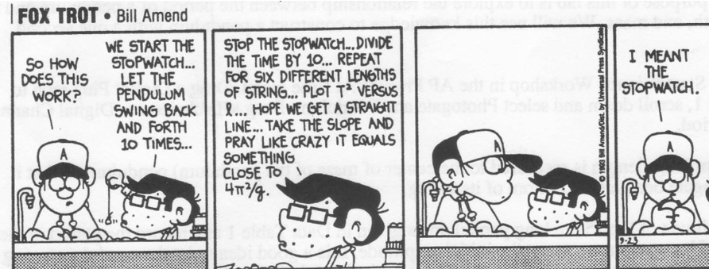

SLOP

State Hooke’s law. | For a stretched string the restoring force is proportional to the extension.
A mass at the end of a spring is an example of a system that obeys Hooke’s Law.  Give another example of a system that obeys this law. | A stretched spring also obeys Hooke’s law.
The equation F = – ks, where k is a constant, is an expression for a law that governs the motion of a body.  Name this law and give a statement of it. | Hooke’s Law  Stretched elastic, pendulum, oscillating magnet, springs of car, vibrating tuning fork.
Define simple harmonic motion | An object is said to be moving with SHM if its acceleration is directly proportional to its displacement from a fixed point in its path, and its acceleration is directed towards that point.
- When a sphere of mass 500 g is attached to a spring of length 300 mm, the length of the spring increases to 330 mm.  Calculate the spring constant. | Force down = mg = (0.5)(g).  Because the spring is in equilibrium this must be equal to the force up (which is the restoring force).  Force down = Force up  ⇒ (0.5)(g) = k(extension)  ⇒ k = F/x = 0.5g/0.030  ⇒ k = 163.3 N m⁻¹
- The sphere is then pulled down until the spring’s length has increased to 350 mm and is then released.  Describe the motion of the sphere when it is released. | It executes simple harmonic motion because the displacement is proportional to the acceleration.
- What is the maximum acceleration of the sphere? | F = ma = k(extension)  ⇒ a = k(extension)/m  = (163.3)(0.02)/(0.5) = 6.532 m s⁻²  OR  a = ω² x ⇒ ω² = k/m  ω² = 163.3/0.5  ⇒ a = 6.532 m s⁻²
- When a small sphere of mass 300 g is attached to a spring of length 200 mm, its length increases to 285 mm.  Calculate its spring constant. | - F = ks  mg = ks  (0.30)(9.8) = (k)(0.085)  k = 34.6 N m⁻¹
- The sphere is pulled down until the length of the spring is 310 mm.  The sphere is then released and oscillates about a fixed point. Derive the relationship between acceleration and displacement from a fixed point for an object undergoing simple harmonic motion. | F = - ks ⇒ ma = - ks  ⇒ a = - (k/m)s  ⇒ a α -s ⇒ a = - k s
- Calculate the period of oscillation of the sphere. | From above: ω² = k/m  ⇒ ω² = 34.6 / 0.3  ⇒ω = 10.7  ⇒T = 2π/ω = 2π/10.7 = 0.58 ≈ 0.6  ⇒ T = 0.6 s
- Calculate the maximum acceleration of the sphere. | This occurs when s is a maximum, i.e. when s = amplitude = 0.310 – 0.285 = 0.025 m.  a = -ω²s ⇒ a = - (10.7)² (0.025)  ⇒ a = (-) 2.89 m s⁻²
- Calculate the length of the spring when the acceleration of the sphere is zero. | This occurs at the fixed point when l = 0.285 m

MECHANICS III EXAM QUESTIONS 2002 – 2023

Force and vectors: Higher level

2022 Question 14 (a) [Higher level]
- Distinguish between a vector and scalar.
- Draw a labelled diagram of the arrangement of the apparatus in an experiment to find the resultant of two vectors.
- An object is released with an initial velocity of 150 m s^{–1} at an angle of 20° to the horizontal.
Resolve the velocity into horizontal and vertical components.
- Calculate the magnitude and direction of the velocity of the object after 8 s.

2018 Question 6 (b) [Higher Level]
During the long jump, Ashton has a velocity of 10.9 m s^{–1} at an angle of 43° to the horizontal when he begins his jump.

He lands 1.03 seconds after he takes off.
- Calculate his velocity in the horizontal direction,
- Calculate the length of the jump.

2020 Question 6 [Higher level]
Motion and the effects of forces can be explained using Newton’s three laws of motion.
- State Newton’s laws of motion.
- Show that F = ma is a special case of Newton’s second law.
- Describe an experiment to find the resultant of two co‐planar vectors.

- A cricket player moves her hands away from the motion of the ball as she catches it.
Use Newton’s laws of motion to explain why she moves her hands away from the motion of the ball.

She then throws a ball upwards with an initial velocity of 28 m s^{–1} at 45° to the horizontal. Her hand was 1.6 m above the ground. A short time later the ball was caught by another player. When it was caught the ball was again at a height of 1.6 m.
Calculate
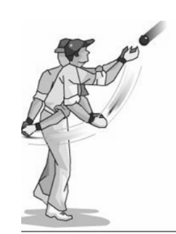
- how long the ball was in the air
- the horizontal distance travelled by the ball
- the maximum height above the ground reached by the ball.
- Draw a diagram to show the velocity v and acceleration a of the ball when it is at its maximum height.
Also show the force(s) F on the ball. Use the letters v, a and F to label your vectors.

2003 Question 6 [Higher Level]
- Give the difference between vector quantities and scalar quantities and give one example of each.
- Describe an experiment to find the resultant of two vectors.
- A cyclist travels from A to B along the arc of a circle of radius 25 m as shown.
- Calculate (i) the distance travelled by the cyclist.
- Calculate the displacement undergone by the cyclist.

- A person in a wheelchair is moving up a ramp at a constant speed. Their total weight is 900 N.
The ramp makes an angle of 10º with the horizontal.
Calculate the force required to keep the wheelchair moving at a constant speed up the ramp. (You may ignore the effects of friction.)
- The ramp is 5 m long. Calculate the power exerted by the person in the wheelchair if it takes her 10 s to travel up the ramp.

2014 Question 6 [Higher Level]
- Compare vector and scalar quantities.
Give one example of each.
- Describe an experiment to find the resultant of two vectors.
- A golfer pulls his trolley and bag along a level path. He applies a force of 277 N at an angle of 24.53° to the horizontal. The weight of the trolley and bag together is 115 N and the force of friction is 252 N.
Calculate the net force acting on the trolley and bag.
- What does the net force tell you about the golfer’s motion?
- Use Newton’s second law of motion to derive an equation relating force, mass and acceleration.
- A force of 5.3 kN is applied to a golf ball by a club.
The mass of the ball is 45 g and the ball and club are in contact for 0.54 ms.
Calculate the speed of the ball as it leaves the club.
- The ball leaves the club head at an angle of 15° to the horizontal.
Calculate the maximum height reached by the ball.
Ignore the effect of air resistance.

Question 7 Higher Level 2023
- State Newton’s third law of motion.

- Show that F = ma is a special case of Newton’s second law of motion.

- A force of 6.8 kN is applied to a golf ball at rest by the head of a golf club.
The ball has a mass of 45.6 g and the club and ball are in contact for a time of 0.51 ms.
Calculate the velocity of the ball immediately after impact.

- The velocity of the ball immediately after impact is at an angle of 15° to the horizontal.
Draw separate diagrams to show the forces acting on the ball
  - during impact,
  - immediately after impact.

- Calculate the maximum height reached by the ball.
- Calculate the time it takes for the ball to travel a horizontal distance of 280 m.
- A wind blows as the ball travels through the air.
The wind has a velocity of 8.2 m s^{–1} east and 3.7 m s^{–1} north.
Calculate the magnitude and direction of the velocity of the wind.
acceleration due to gravity = 9.8 m s^{–2}
2009 Question 6 [Higher Level]
- State Newton’s laws of motion.
- Show that F = ma is a special case of Newton’s second law.

A skateboarder with a total mass of 70 kg starts from rest at the top of a ramp and accelerates down it. The ramp is 25 m long and is at an angle of 20⁰ to the horizontal.
The skateboarder has a velocity of 12.2 m s^{–1} at the bottom of the ramp.

- Calculate the average acceleration of the skateboarder on the ramp.
- Calculate the component of the skateboarder’s weight that is parallel to the ramp.
- Calculate the force of friction acting on the skateboarder on the ramp.
- The skateboarder then maintains a speed of 10.5 m s^{–1} until he enters a circular ramp of radius 10 m.
What is the initial centripetal force acting on him?
- What is the maximum height that the skateboarder can reach?
- Sketch a velocity-time graph to illustrate his motion.

2022 Deferred Question 7 [Higher Level]
- Define displacement.
- Define velocity.
- What is a vector quantity?

A swimmer wants to cross a river which is 75 m wide. The banks of the river are parallel.
The river is flowing with a velocity of 4 m s^{–1} parallel to the river banks, as in the diagram.
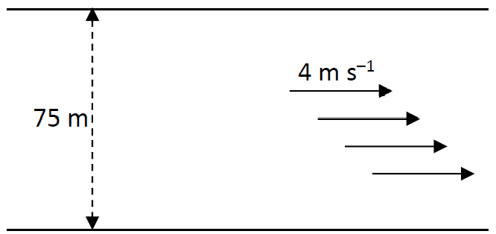

The swimmer sets out to swim across the river with a speed of 2.5 m s^{–1} perpendicular to the banks of the river.
- What is the resultant velocity of the swimmer?
- How long will it take the swimmer to reach the opposite bank of the river?
- What will be the displacement of the swimmer from his starting position when he has reached the opposite bank?
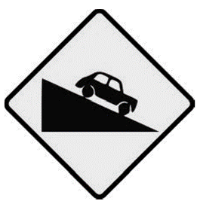
- Describe a laboratory experiment to find the resultant of two co‐planar forces.
- A car of mass 1000 kg is freely rolling downhill on a road that is at an angle of 10° to the horizontal.
If the frictional force on the car as it moves down the slope is a constant 550 N, calculate the acceleration of the car.
(acceleration due to gravity, g = 9.8 m s⁻²)

Circular motion: All Higher level

Question 13 Higher Level 2023
- A flywheel of diameter 1.4 m rotates with 5000 revolutions per minute.
Calculate
  - the period (in s) of the flywheel’s motion,
  - the angular velocity of the flywheel,
  - the centripetal acceleration at the circumference of the flywheel.

2022 Question 7 {second half}
- The object is now detached from the spring and attached to the end of a string of fixed length 11 cm.
It is made to rotate in a vertical circle with constant angular velocity and with a period of 0.5 s.
Derive an expression for the linear velocity of an object moving in circular motion in terms of its angular velocity and the radius of the circle.
- Calculate (a) the angular velocity, (b) the linear velocity of the object.
- Calculate the minimum tension in the string.
- Draw a labelled diagram of the forces acting on the object when the string has its minimum tension.

2012 Question 12 (a)
An Olympic hammer thrower swings a mass of 7.26 kg at the end of a light inextensible wire in a circular motion. In the final complete swing, the hammer moves at a constant speed and takes 0.8 s to complete a circle of radius 2.0 m.
- What is the angular velocity of the hammer during its final swing?
- Even though the hammer moves at a constant speed, it accelerates. Explain.
- Calculate the acceleration of the hammer during its final swing
- Calculate the kinetic energy of the hammer as it is released.

2018 Question 6 (a)
During the discus event, Ashton swings a discus of mass 2.0 kg in uniform circular motion. The radius of orbit of the discus is 1.2 m and the discus has a velocity of 20.4 m s^{–1} when Ashton releases it.
- Derive an expression to show the relationship between the radius, velocity and angular velocity of an object moving in uniform circular motion.
- Calculate the angular velocity of the discus immediately prior to its release.
- Calculate the centripetal force acting on the discus just before Ashton releases it.
- In what direction does this force apply?

2011 Question 6 (c)
A simple merry-go-round consists of a flat disc that is rotated horizontally.
A child of mass 32 kg stands at the edge of the merry-go-round, 2.2 metres from its centre.
The force of friction acting on the child is 50 N.
Draw a diagram showing the forces acting on the child as the merry-go-round rotates.

What is the maximum angular velocity of the merry-go-round so that the child will not fall from it, as it rotates?
If there was no force of friction between the child and the merry-go-round, in what direction would the child move as the merry-go-round starts to rotate?

2006 Question 6
- Define velocity.
- Define angular velocity.
- Derive the relationship between the velocity of a particle travelling in uniform circular motion and its angular velocity.
- A student swings a ball in a circle of radius 70 cm in the vertical plane as shown. The angular velocity of the ball is 10 rad s^{–1}.
What is the velocity of the ball?
- How long does the ball take to complete one revolution?
- Draw a diagram to show the forces acting on the ball when it is at position A.
- The student releases the ball when is it at A, which is 130 cm above the ground, and the ball travels vertically upwards. Calculate the maximum height, above the ground, the ball will reach.
- Calculate the time taken for the ball to hit the ground after its release from A.

2019 Question 12 (a)
State the principle of conversation of energy.
- A mass hanging at the end of a string of length 80 cm is given an initial horizontal velocity of 4 m s^{–1}. Calculate the velocity of the mass at position B,
- Calculate its centripetal acceleration at position B.
- Draw a labelled diagram to show the forces acting on the mass when it is at position B.

(acceleration due to gravity = 9.8 m s^{–2})

2016 Question 12 (c)
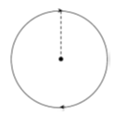
{The other part of 12 (c) was related to the Doppler effect, which I put into the “Waves, Sound and Light” long questions}

- Define centripetal force.
- A buzzer attached to a string of length 80 cm moves at a speed of 13 m s^{–1} in a vertical circle.
The buzzer has a mass of 70 g. Calculate the maximum and minimum tension in the string.
{This is another sh1t question, because the speed at the bottom should be greater than the speed at the top, but here they simply tell you that it is 13 m s⁻¹ in both cases.}

Circular motion and gravity: all Higher level

2019 Question 6 [Higher level]
{I’m sure there is a good reason for including images like the ones in this question on exam papers. I just don’t see it}
Satellites, which play an increasing role in the information age, are controlled by the gravitational force. Weather satellites, communications satellites and global positioning satellites (GPS) are used by millions of people every day. Different satellites have different periods and different radii of orbit.
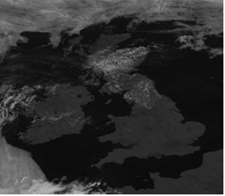
- State Newton’s law of universal gravitation.
- What is the relationship between the period T and radius of orbit r of a satellite?
- METEOSAT 11 weather satellite provides MET Éireann with both visible and infrared images.
It is in geostationary orbit above the equator.
Which has a longer wavelength, visible or infrared radiation?
- Describe how infrared radiation can be detected in the school laboratory.
- What is the period of METEOSAT 11?
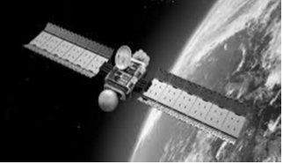
- Calculate its height above the surface of the Earth.
- A global positioning satellite is not in geostationary orbit.
It orbits the Earth with a speed of 14000 km hr^{‐1}.
Calculate its radius of orbit.
- Calculate its angular velocity.
- Calculate the minimum time it takes a signal to travel from the global positioning satellite to the Earth.
- Explain why satellites remain in orbit and do not fall to Earth.
(mass of Earth = 6.0 × 10²⁴ kg, radius of Earth = 6400 km)

2004 Question 12 (a) [Higher level]
- State Newton’s universal law of gravitation.
- Centripetal force is required to keep the earth moving around the sun.
What provides this centripetal force?
- In what direction does this centripetal force act?
- Give an expression for centripetal force.
- The earth has a speed of 3.0 × 10⁴ m s^{–1} as it orbits the sun.
The distance between the earth and the sun is 1.5 × 10¹¹ m
Calculate the mass of the sun.
(gravitational constant G = 6.7 × 10^{–11} m³ kg^{–1} s^{–2})

2022 Question 13 [Second half]
- The pendulum of Huygens’ clock oscillated with a period of 2 s. Calculate the length of this pendulum.
- Titan orbits Saturn every 15.9 Earth days. The surface of Titan is 1.16 × 10⁹ m above the surface of Saturn.
Calculate the mass of Saturn
- Calculate the acceleration due to gravity on the surface of Saturn
- Calculate the period that Huygens’ clock would have on the surface of Saturn.
(acceleration due to gravity on Earth = 9.8 m s^{–2}; radius of Saturn = 58200 km; radius of Titan = 2570 km)

2013 Question 6 [Higher level]
- State Newton’s law of universal gravitation.
- Explain what is meant by angular velocity.
- Derive an equation for the angular velocity of an object in terms of its linear velocity when the object moves in a circle.

The International Space Station (ISS), shown in the photograph, functions as a research laboratory and a location for testing of equipment required for trips to the moon and to Mars.
The ISS orbits the earth at an altitude of 4.13 × 10⁵ m every 92 minutes 50 seconds.

- Calculate (a) the angular velocity, (b) the linear velocity, of the ISS.
- Name the type of acceleration that the ISS experiences as it travels in a circular orbit around the earth.
- What force provides this acceleration?
- Calculate the attractive force between the earth and the ISS.
- Hence or otherwise, calculate the mass of the earth.

- If the value of the acceleration due to gravity on the ISS is 8.63 m s⁻², why do occupants of the ISS experience apparent weightlessness?
- A geostationary communications satellite orbits the earth at a much higher altitude than the ISS.
What is the period of a geostationary communications satellite?
(mass of ISS = 4.5 × 10⁵ kg; radius of the earth = 6.37 × 10⁶ m)

2008 Question 6 [Higher level]
- State Newton’s law of universal gravitation.
- The international space station (ISS) moves in a circular orbit around the equator at a height of 400 km.
What type of force is required to keep the ISS in orbit?
- What is the direction of this force?
- Calculate the acceleration due to gravity at a point 400 km above the surface of the earth.
- An astronaut in the ISS appears weightless. Explain why.
- Derive the relationship between the period of the ISS, the radius of its orbit and the mass of the earth.
- Calculate the period of an orbit of the ISS.
- After an orbit, the ISS will be above a different point on the earth’s surface. Explain why.
- How many times does an astronaut on the ISS see the sun rise in a 24 hour period?
(gravitational constant = 6.6 × 10^{–11} N m² kg^{–2;} mass of the earth = 6.0 × 10²⁴ kg;
radius of the earth = 6.4 × 10⁶ m)

2005 Question 6 [Higher level]
- Define angular velocity.
- Define centripetal force.
- State Newton’s Universal Law of Gravitation.
- A satellite is in a circular orbit around the planet Saturn.
Derive the relationship between the period of the satellite, the mass of Saturn and the radius of the orbit.
- The period of the satellite is 380 hours. Calculate the radius of the satellite’s orbit around Saturn.
- The satellite transmits radio signals to earth. At a particular time the satellite is 1.2 × 10¹² m from earth. How long does it take the signal to travel to earth?
- It is noticed that the frequency of the received radio signal changes as the satellite orbits Saturn. Explain why.
Gravitational constant = 6.7 × 10^{–11} N m² kg^{–2}
mass of Saturn = 5.7 × 10²⁶ kg
speed of light = 3.0 × 10⁸ m s^{–1}

2015 Question 6 [Higher level]
In the circular orbit of a satellite around the Earth, the required centripetal force is the gravitational force between the satellite and the Earth.
The force can be determined using Newton’s law of universal gravitation.
- Explain what is meant by centripetal force.
- State Newton’s law of universal gravitation.
- Derive the relationship between the period of a satellite, the radius of its orbit and the mass of the Earth.

A Global Positioning Systems (GPS) receiver can calculate its position on Earth to within a few metres.
It picks up radio-wave signals from several of the 32 GPS satellites orbiting the Earth.
GPS satellites orbit the Earth in Medium Earth Orbit (MEO) with a period of 12 hours.

- Calculate the height of a GPS satellite above the Earth’s surface.
- Calculate the speed of a GPS satellite.
- Calculate the minimum time it takes a GPS signal to travel from the satellite to a receiver on the surface of the Earth.
- Explain why GPS satellites are not classed as geostationary satellites.
- Radio-waves, such as those used by GPS satellites, have the lowest frequency of all electromagnetic radiation types.
What type of electromagnetic radiation has the next lowest frequency?
(mass of Earth = 5.97 × 10²⁴ kg; radius of Earth = 6371 km)

2020 Question 12 (a) [Higher level]

Fifty years ago the Apollo 13 mission to the Moon captured the public’s imagination when technical issues led to the aborting of the planned Moon landing. The three astronauts on the mission travelled further from the Earth than anyone before or since.

- Derive an expression for the period of orbit T of the Moon when it has a radius of orbit R around the Earth (of mass M).
- Calculate the period of the Moon as it orbits the Earth.
- Calculate the gravitational force exerted by the Moon on an astronaut of mass 80 kg when he is 250 km above the surface of the Moon.
- Astronauts appear to be weightless when they orbit the Moon. Explain why.

mass of Earth = 6.0 × 10²⁴ kg
mass of the Moon = 7.3 × 10²² kg
radius of the Moon = 1740 km
radius of the Moon’s orbit around Earth = 3.85 × 10⁸ m

2022 Question 13 [Higher level]

Read the following passage and answer the accompanying questions.

Europe’s greatest scientist during the latter half of the seventeenth century, Christiaan Huygens, was a true polymath. He was a towering figure in the fields of astronomy, mechanics and mathematics, and many of his innovations in methodology, optics and timekeeping remain in use to this day. Among his many achievements, he developed the theory of light travelling as a wave, he invented the mechanism for the pendulum clock, and he discovered the rings of Saturn and its moon Titan – via a telescope that he also had invented.
Huygens is remembered as a problem solver: pragmatic, eclectic and synthetic, sceptical and ready to settle for the most probable rather than hold out for the absolutely certain – in other words, what we expect a scientist to be today.
Adapted from: ‘Dutch Light: Christiaan Huygens and the Making of Science in Europe’
(Hugh Aldersey-Williams) Pan Macmillan 2020
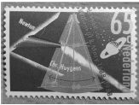
- Diffraction is one of the wave properties of light.
What is meant by diffraction?
- Draw a labelled diagram of an experiment to demonstrate the wave nature of light.
- What is observed in this experiment?
- How do the observations demonstrate the wave nature of light?
- The eyepiece lens of Huygens’ telescope was a converging lens arranged so as to produce a virtual image. Draw a ray diagram to show how a converging lens can produce a virtual image.
- The pendulum of Huygens’ clock oscillated with a period of 2 s. Calculate the length of this pendulum.
- Titan orbits Saturn every 15.9 Earth days. The surface of Titan is 1.16 × 10⁹ m above the surface of Saturn.
Calculate the mass of Saturn
- Calculate the acceleration due to gravity on the surface of Saturn
- Calculate the period that Huygens’ clock would have on the surface of Saturn.
(acceleration due to gravity on Earth = 9.8 m s^{–2}; radius of Saturn = 58200 km; radius of Titan = 2570 km)

Simple harmonic motion: all Higher level
2011 Question 12 (a)
State Hooke’s law.
A body of mass 250 g vibrates on a horizontal surface and its motion is described by the equation a = – 16 s, where s is the displacement of the body from its equilibrium position.
The amplitude of each vibration is 5 cm.
- Why does the body vibrate with simple harmonic motion?
- Calculate the frequency of vibration of the body?
- What is the magnitude of (i) the maximum force, (ii) the minimum force, acting on the body?

2013 Question 11
Read the following passage and answer the accompanying questions.

A seismometer consists of a sensor that detects ground motion, attached to a recording system.
A seismometer that is sensitive to up-down motions of the ground, as caused by an earthquake, can be understood by visualising a mass hanging on a spring as shown in the diagram.
The frame and the drum move up and down as the seismic wave passes by, but the mass remains stationary.
If a recording system is installed, such as a rotating drum attached to the frame and a pen attached to the mass, this relative motion between the suspended mass and the ground can be recorded to produce a seismogram, as shown in the diagram.
Modern seismometers do not use a pen and drum.
The relative motion between a magnet that is attached to the mass, and the frame, generates a potential difference that is recorded by a computer.
(Adapted from www.iris.edu Education and Outreach Series No.7: How does a Seismometer Work?)

- Seismic waves can be longitudinal or transverse.
What is the main difference between them?
- An earthquake generates a seismic wave that takes 27 seconds to reach a recording station. If the wave travels at 5 km s⁻¹ along the earth’s surface, how far is the station from the centre of the earthquake?
- Draw a diagram to show the forces acting on the suspended mass when the seismometer is at rest.
- At rest, the tension in the spring is 49 N. What is the value, in kilograms, of the suspended mass?
- What type of motion does the frame have when it moves relative to the mass?
- During an earthquake the ground was observed at the recording station to move up and down as the seismic wave generated by the earthquake passed. Give an equation for the acceleration of the ground in terms of the periodic time of the wave motion and the displacement of the ground.
- If the period of the ground motion was recorded as 17 seconds and its amplitude was recorded as 0.8 cm, calculate the maximum ground acceleration at the recording station.
- In some modern seismometers a magnet is attached to the mass and a coil of wire is attached to the frame. During an earthquake, there is relative motion between the magnet and the coil.
Explain why an emf is generated in the coil.
- (acceleration due to gravity, g = 9.8 m s⁻²)

Simple harmonic motion with Hooke’s law: all Higher level

Tricky maths questions - points to note
- When using the F = k s expression for Hooke’s law, note that s represents the extension, i.e. the distance between the new length and the end of the natural length.
However when using the expression for simple harmonic motion (a = -ω² s) s represents the distance between the new length and the equilibrium position.
$$ω= \sqrt{\frac{k}{m}}$$

- Remember that the most common equation used here is the following:

2017 Question 6
In a bungee jump, Henry falls while attached to an elastic cord.
When the cord stops Henry’s fall, he then oscillates up and down.
During the bungee jump, gravitational potential energy is converted into kinetic energy and then into elastic potential energy.
- State the principle of conservation of energy.
- Derive the expression v²=u²+2as for uniform accelerated motion.
- The cord is 32 m long and Henry, of mass 60 kg, falls from rest while attached. Calculate his speed when he has fallen 16 m.

A stretched elastic cord obeys Hooke’s law and the weight attached to the cord oscillates with simple harmonic motion.
- State Hooke’s law.
- What is meant by simple harmonic motion?
- The elastic constant of the cord is 250 N m^{–1}.
Calculate the length the cord would have if Henry was suspended at rest.

After the end of the fall, Henry oscillates with simple harmonic motion.
The maximum displacement from his rest position is 1.2 metres.
- Calculate (i) his maximum acceleration as he oscillates and (ii) his period of oscillation.
- Draw a diagram to show the forces acting on Henry when he is at his lowest point.
(acceleration due to gravity, g = 9.8 m s^{–2})

2014 Question 12 (a)
- State Hooke’s law.
- The elastic constant of a spring is 12 N m^{–1} and it has a length of 25 mm.
An object of mass 20 g is attached to the spring.
What is the new length of the spring?
- The object is then pulled down until the spring’s length is increased by a further 5 mm and is then released. The object oscillates with simple harmonic motion.
Sketch a velocity-time graph of the motion of the object.
- Calculate the period of oscillation of the object.
(acceleration due to gravity, g = 9.8 m s⁻²)

2009 Question 12 (a)
- State Hooke’s law.
- When a sphere of mass 500 g is attached to a spring of length 300 mm, the length of the spring increases to 330 mm.
Calculate the spring constant.
- The sphere is then pulled down until the spring’s length has increased to 350 mm and is then released.
Describe the motion of the sphere when it is released.
- What is the maximum acceleration of the sphere?
(acceleration due to gravity = 9.8 m s⁻²)

2007 Question 6
- State Hooke’s law.
- A stretched spring obeys Hooke’s law.
When a small sphere of mass 300 g is attached to a spring of length 200 mm, its length increases to 285 mm.
Calculate its spring constant.
- The sphere is pulled down until the length of the spring is 310 mm.
The sphere is then released and oscillates about a fixed point.
Derive the relationship between the acceleration of the sphere and its displacement from the fixed point.
- Why does the sphere oscillate with simple harmonic motion?
- Calculate the period of oscillation of the sphere
- Calculate the maximum acceleration of the sphere
- Calculate the length of the spring when the acceleration of the sphere is zero.
(acceleration due to gravity = 9.8 m s^{–2})

2018 Question 12 (a)
A simple pendulum can execute simple harmonic motion.
- Explain the underlined term.
- When does a simple pendulum execute simple harmonic motion?
- What is the relationship between the period and the length of a simple pendulum?

A stretched spring can also execute simple harmonic motion.
A spring has a natural length of 50 cm.
A mass of 60 g is hung from the spring and the mass is allowed to oscillate with simple harmonic motion.
It has a period of oscillation of 0.85 seconds.

- Calculate the spring constant,
- Calculate the length of the spring when the mass is at rest.
(acceleration due to gravity = 9.8 m s^{–2})

2021 Question 14 (a)
An iron sphere of mass 40 g hangs from a spring and oscillates with simple harmonic motion.
The period of oscillation is 0.74 s.
- What is simple harmonic motion?
- Calculate the spring constant.
- Calculate the acceleration of the sphere when its displacement is 18 mm from its equilibrium position.

The iron sphere and the spring are brought to rest and a small magnet is attached to the sphere.
When the magnet is attached to the sphere, the length of the spring increases by 15 mm.
- Calculate the mass of the magnet.
(acceleration due to gravity = 9.8 m s^{–2})

2022 Question 7 {first half}
A spring of natural length 150 mm obeys Hooke’s law.
When an object of mass 200 g is attached to it, the length of the spring increases to 185 mm.
- State Hooke’s law.
- Calculate the elastic constant of the spring.
- The object is pulled down until the spring has a length of 200 mm.
The object is then released. It moves with simple harmonic motion.
Calculate the period of oscillation of the object.
- Calculate the maximum acceleration of the object.
- What is the speed of the body when it has maximum acceleration?

2023 Question 14 (a) Higher Level
In 1660 Robert Hooke investigated the elasticity of materials, including springs.
His work led to Hooke’s law.
- State Hooke’s law.

A spring has a natural length of 15.0 cm. When a block of mass 500 g is hung from the spring, its length increases to 17.5 cm. The block is then pulled down further, released and begins to oscillate.
- Calculate the elastic constant of the spring.
- Calculate the period of oscillation of the block.

- In 1665 Hooke, working as an assistant to Robert Boyle, built the vacuum pump that was used in the experiment that led to Boyle’s law.
Sketch a graph that explains Boyle’s law. Label the axes on your graph.
acceleration due to gravity = 9.8 m s^{–2}

2022 Deferred Question 14 (a) [Higher Level]
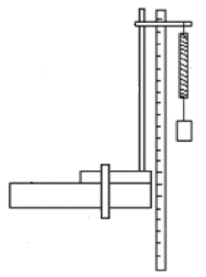
- State Hooke’s law.
- The length of the spiral spring in the diagram increases from 50 cm to 56 cm when a body of weight 0.7 N is hung from the spring.
Calculate the elastic constant of the spring.

When the body at the end of the spring is pulled down by a further short distance and then released, the mass oscillates with simple harmonic motion.
- Calculate the period of the simple harmonic motion.
At what point during its oscillation does the body have (iv) maximum velocity, (v) maximum acceleration?

2002 Question 6
- State Newton’s second law of motion.
- The equation F = – ks, where k is a constant, is an expression for a law that governs the motion of a body.
Name this law and give a statement of it.
- Give the name for this type of motion and describe the motion.
- A mass at the end of a spring is an example of a system that obeys this law.
Give two other examples of systems that obey this law.
- The springs of a mountain bike are compressed vertically by 5 mm when a cyclist of mass 60 kg sits on it.
When the cyclist rides the bike over a bump on a track, the frame of the bike and the cyclist oscillate up and down.
Using the formula F = – ks, calculate the value of k, the constant for the springs of the bike.
- The total mass of the frame of the bike and the cyclist is 80 kg.
Calculate (i) the period of oscillation of the cyclist, (ii) the number of oscillations of the cyclist per second. (acceleration due to gravity, g = 9.8 m s⁻²)
2016 Question 6
A mass at the end of a spring obeys Hooke’s law.
The mass can be made to oscillate vertically, so that it executes simple harmonic motion.
- Explain the underlined term.
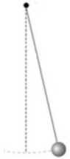
- State Hooke’s law.
- Use Hooke’s law to show that the mass executes simple harmonic motion.

A simple pendulum also executes simple harmonic motion.
The time taken for each oscillation of a certain simple pendulum on the Earth’s surface is 2 s.
The weight of its bob is 3.5 N.
The bob travels along a curved path.
It travels a distance of 18 cm during each oscillation.
- Calculate the length of the pendulum
- Calculate the maximum angular displacement of the pendulum.

- Draw a diagram to show the forces acting on the bob when it is at its maximum displacement.
- Calculate the restoring force at this point.
- At what point during its movement does the bob have its greatest angular velocity?
- The period of a simple pendulum varies with its height above the surface of the Earth.
At what height will the period of a simple pendulum be 2% more than the period of a simple pendulum of the same length at the Earth’s surface?
Show your work clearly.
(acceleration due to gravity at the Earth’s surface = 9.8 m s^{–2}; radius of Earth = 6371 km)

Trivia question: Who was the first person to use the terms “scalar” and “vector” in their modern form? Answer: Irish mathematician, astronomer, and physicist William Rowan Hamilton (1805 – 1865). Hamilton is just another in a long list of famous Irish scientists which we have ignored for over 100 years, partly because their Protestant background didn’t align with our outdated sense of what Irish people should be. The vast majority of our scientists were Protestant (mostly because they had the time and money to support their own research). As a result one of the first subjects to disappear from the primary school curriculum when the Irish state came into existence was science - in order to make room for Irish. Science was only re-introduced into the primary school curriculum in recent years. Hamilton’s greatest contribution to science is his discovery of ‘quaternions’; these are now widely used in the world of robotics, computer animation and special effects in movies.
Why do so many students find vectors confusing? Because we usually talk about vectors without given examples of where (or why) we use them, so they become even more abstract concepts than they should or need to be. We can overcome this difficulty (in part) by giving lots of examples of resolving vectors and then using the information gained from this to solve a related problem. I think it was Galileo who first realised that you can split vectors into components like this. Imagine being the only person who had ever lived up to that point to be aware of this fantastic concept. Sure you couldn’t make it up.
“Now we are going to do the one problem that has sent more people away from physics than anything else. It is called the inclined plane. A lot of people who do not know where they were during the Kennedy assassination say, “I remember the day I saw the inclined plane; that’s the day I decided I’m not going into physics.” This is very bad publicity for our field. You come into a subject hearing about relativity and quantum physics and then we hit you with this. So why am I still doing this? Because this is the entry ticket into the business. It is inconceivable to me that you could understand more advance topics without being able to understand this one. Go ahead and mock the inclined plane, but only after you can prove you have mastered it.” Professor R. Shankar (Yale University) writing in his university textbook Fundamentals of Physics. He is one cool dude. Check out his classes on YouTube.
It’s not obvious that both angles in the diagrams here are the same – can you show why they are?
Remember that a vector has both magnitude and direction.
This topic is Higher Level only. By the way, did you know that a day on Venus is longer than a year on Venus? Can you say why?
Angles can also be measured in something called radians So why do we use radians? Well we’re used to dividing a circle up into 360⁰, but that’s completely arbitrary; it could be 100⁰, 200⁰ or just about anything else you want it to be. It seems to go all the way back to the Mesopotamians over 6,000 years ago, who liked to work with the number 60, partly because it could be divided up so many different ways, i.e. 1, 2, 3, 4, 5, 6, 9, 12, 24 and 30. This got picked up by the Babylonians and passed on to the Egyptians. And from there to us. The circle has 6 × 60, or 360 parts. It also seems that they used the sections in their fingers to count. You have three sections in each finger so (ignoring your thumb) you have 12 sections in total on each hand. Radians however are not arbitrary. If θ is defined as arc length divided by radius, and we apply this to the number of radians in a full circle, we get arc length (which in this case is circumference of a circle - 2πr) divided by the radius r. This gives us 2π radians. i.e. 360 (degrees) = 2π (radians). It’s also worth pointing out that calculus is much more elegant when working in radians rather than degrees. You may have noticed on your calculator that the grad is another unit. Apparently some engineers use this unit. There are 400 grads in a circle.
Does this seem strange? Of course it does – we have never come across anything like this before. But just because something is unfamiliar doesn’t make it complex. Nobody describes the magic in Harry Potter as complex, just bizarre. And then once you become familiar with Harry Potter books even the magic there doesn’t seem strange after a while. So what I’m trying to say (in my usual very roundabout way) is that we shouldn’t be intimidated by these concepts. After all, it’s not rocket science. Or is it?
We need to consider vectors which we have just come across in the previous chapter. Consider the centripetal force acting on an object as shown in the diagram above. The object could be a stone swinging around on the end of a string or the moon going around the Earth. Notice that the object is moving tangentially to the circle and also that the force is perpendicular to this direction. There is therefore no component of the force acting either towards or opposite to the direction that the particle is moving. Therefore that force F cannot speed up or slow down the particle’s motion. Yet it is definitely acting on the particle so it must cause the particle to accelerate in some way. What’s the only way that the particle can accelerate without changing speed? That’s right – by changing direction. And every time it changes direction, the direction of the inward force adjusts also so the process continues. I was today year’s old when I first made that connection.
Centripetal means ‘centre seeking’. The term itself is the source of so many misconceptions. It’s not even a force, merely an umbrella term for any force or forces causing an object to undergo circular motion. I would do away with the term completely at secondary level if I could.
Why so many bloomin’ formulae? Honestly? I’m just glad it’s you and not me who has to know them. For what it’s worth, none actually need to be learned off by heart; ω = θ/t comes directly from the definition of angular velocity and θ = s/r comes directly from the definition of a radian. v = rω is obtained by dividing the previous equation by t on both sides (and this derivation needs to be known anyway). The two formulae for acceleration are in the Formula and Tables book page 51 The amount of formulae that need to be learned in Physics can be rather intimidating so any help you can get to alleviate your suffering should be availed of. This chapter contains more formulae than most and possibly as a result of this students often try to avoid questions on circular motion when they can. A useful revision activity is to get a sheet of A4 paper and put all these equations on it, showing how they are interconnected. Taking a ‘big picture’ approach like this should help to reduce the intimidation factor. Good luck with that.
Simple harmonic motion: Up to this point we only considered forces (and therefore accelerations) that were constant in magnitude. An object undergoing SHM has an equilibrium position point, and if it gets disturbed from this point then it’s acceleration towards the equilibrium position will be proportional to its displacement from that point. In other words its acceleration is constantly changing.
“But I thought ω represented angular velocity?” ω is the same symbol as was used in the previous topic (Circular Motion) to represent angular velocity, however it does not represent angular velocity here. It’s not just coincidence that ω turns up in both chapters; they are connected, but the relationship is a little complicated. See some of the links on thephysicsteacher for more on this.
Why the term ‘simple harmonic motion’? Presumably because it is a type of periodic motion that can be described mathematically by a simple harmonic function, such as a sine or cosine wave.
Recap - In Linear Acceleration, acceleration is always constant in magnitude and direction. - In Circular Motion, acceleration is always constant in magnitude but not direction - In SHM, acceleration by its nature is not constant in either magnitude direction.
Robert Hooke and Isaac Newton Robert Hooke was probably Britain’s foremost scientist (or ‘natural philosopher’ as they were then known) when Newton first came to prominence. Over the following years the men became bitter enemies, to the extent that when Newton replaced Hooke as president of the Royal Society in England, the painting of Hooke which had pride of place in the building mysteriously went missing shortly after Newton replaced him. One reason they fell out was because Hooke was a mechanist. He believed that it was the scientist’s job to engage with nature’s causes – the cause of light, of gravity and so on – and how these causes produce effects that we can detect with instruments. Newton, on the other hand, saw physics as concerned with the mathematical expression of effects. For Newton the true causes of nature, being divine, were beyond the business of science. This explains why Newton could describe the size of the gravitational force between two objects but wasn’t particularly concerned with how it worked. “Gravity must be caused by an agent acting constantly according to certain laws,” he admitted. “But whether this agent be material or immaterial, I have left to the consideration of my readers.”
Note that this formula is only valid for small angles of oscillation (about 5⁰). This motion is isochronous, meaning that the time to do one full oscillation remains constant even as the arc-length gets smaller (because while it’s travelling a shorter distance the speed also slows down.).

